UNIVERSITY OF ENERGY AND NATURAL RESOURCES (UENR)
DEPARTMENT OF INFORMATION TECHNOLOGY & DECISION SCIENCES

AUTOMATED DETECTION AND CLASSIFICATION OF PHOTOVOLTAIC PANEL DEFECTS USING YOLOv8 WITH TFLITE MOBILE INTEGRATION

BY:
• Monica Gyamfuah
• Abubakari Rafiatu
• Owusu Emmanuel
• Agyekum Isaac
• Asare Solomon William
SUPERVISED BY: Dr. Samuel O. Frimpong
A Project Report Submitted to the Department of Information Technology & Decision Sciences
in Partial Fulfillment of the Requirements for the Award of the Degree of Bachelor of Science in
Information Technology
Sunyani, Ghana
JUNE, 2026

DECLARATION
Student's Declaration
Following Dr. Samuel O. Frimpong's guidance, we the undersigned affirm that this project report, "Automated Detection and Classification of Photovoltaic Panel Defects Using YOLOv8 with TFLite Mobile Integration," is our original research work. All citations, sources, and references used to produce this report have been duly acknowledged and referenced in compliance with academic standards. This work has not been presented, in whole or in part, for the award of any degree or certification in this university or elsewhere.
• Monica Gyamfuah (Index: UG01/IT/22/014) — Signature: ______________ — Date: _________
• Abubakari Rafiatu (Index: UG01/IT/22/028) — Signature: ______________ — Date: _________
• Owusu Emmanuel (Index: UG01/IT/22/045) — Signature: ______________ — Date: _________
• Agyekum Isaac (Index: UG01/IT/22/062) — Signature: ______________ — Date: _________
• Asare Solomon William (Index: UG01/IT/22/089) — Signature: ______________ — Date: _________
Supervisor's Declaration
I hereby declare that the preparation and presentation of this project report were supervised by me in accordance with the guidelines on supervision of project work laid down by the University of Energy and Natural Resources (UENR).
Supervisor Name: Dr. Samuel O. Frimpong Signature: _____________________ Date: _________________________

DEDICATION
We dedicate this project to Almighty God for His grace, direction, and strength, which have brought us to this point. We dedicate this work to our parents, guardians, and families for their continuous love, prayers, financial support, and encouragement throughout our academic journey. We also owe a debt of gratitude to our lecturers and project supervisor in the Department of Information Technology and Decision Sciences, whose patience, critique, and guidance inspired us to pursue academic and professional excellence. Lastly, this work is dedicated to our peers, technical staff, and friends who supported us through our setbacks and successes.

ACKNOWLEDGEMENTS
We sincerely thank the Almighty God for giving us the courage, insight, and understanding to complete this project. We owe a great deal of gratitude to our supervisor, Dr. Samuel O. Frimpong, whose invaluable guidance, constructive critique, and continuous feedback shaped the methodology of this research. We also extend sincere gratitude to the University of Energy and Natural Resources (UENR) for providing the resources and clean energy laboratory infrastructure that supported our field evaluations. We also thank Mr. Joshua A. Weyori for his selfless effort and unwavering support during the documentation process. Finally, our appreciation goes to the peer reviewers, technical staff, and faculty of the Department of Information Technology and Decision Sciences for their constructive engagement throughout this work.

ABSTRACT
Photovoltaic (PV) installations are critical to sustainable clean energy generation in Ghana. However, outdoor solar modules are highly susceptible to cell anomalies—including silicon micro-cracks, dust/dirt accumulation (soiling), and electrical hotspots—which severely degrade power generation yield and can cause permanent module destruction. Undetected defects result in global revenue losses exceeding $10 Billion annually (Raptor Maps, 2025). This project presents SolarScan AI, an automated, edge-deployed diagnostic inspection system designed for offline field environments.
We fine-tuned a custom YOLOv8 object detection framework (Jocher et al., 2023) model on real-world PV defect datasets and converted the network weights to a TensorFlow Lite (TFLite) INT8 quantized format for mobile device integration. To protect the AI pipeline from false alarms, a double-layer gatekeeper validates image uploads: a background COCO detector filters out everyday objects with confidence thresholds above 0.12, while color space histograms filter out green vegetation and flat plain textures. Once verified, a wafer thermodynamics engine executes Nominal Operating Cell Temperature (NOCT) thermal modeling (Duffie & Beckman, 2013) physics equations to dynamically calculate operating cell temperatures and actual wattage capacity drops (in Watts) based on solar irradiance inputs.
The final quantized 3.2 MB model achieves a mean Average Precision (mAP@50) of 92.7% with sub-150ms inference latency on standard mobile hardware. Usability testing with field technicians yielded a System Usability Scale (SUS) standardized questionnaire (Brooke, 1996) score of 84.3 out of 100, demonstrating high field utility and ease of deployment for digitalization of solar farm maintenance.
Keywords: Photovoltaic Systems, YOLOv8, TensorFlow Lite, Edge Computing, INT8 Quantization, Double-Layer Validation, Wafer Thermodynamics, NOCT Modeling, System Usability Scale.

TABLE OF CONTENTS
Declaration ......................................................... i
Approval and Certification .......................................... ii
Dedication .......................................................... iii
Acknowledgements .................................................... iv
Abstract ............................................................ v
Table of Contents ................................................... vi
List of Tables ...................................................... viii
List of Figures ..................................................... ix
List of Abbreviations and Acronyms .................................. xi
CHAPTER 1: INTRODUCTION ............................................. 1
1.1 Background of the Study ...................................... 1
1.2 The Photovoltaic Degradation Problem in Equatorial Climates .. 3
1.3 Breakdown of Conventional Inspection Regimes in Rural Africa . 5
1.4 Problem Statement ............................................ 7
1.5 Research Questions ........................................... 8
1.6 Aim and Objectives of the Project ............................ 9
1.7 Significance of the Study .................................... 10
1.8 Scope and Delimitations of the Study ......................... 11
1.9 Organization of the Thesis Report ............................ 12
CHAPTER 2: LITERATURE REVIEW ........................................ 14
2.1 Introduction & Theoretical Physics of Photovoltaic Conversion 14
2.2 Comprehensive Taxonomy of Photovoltaic Degradation Mechanisms 17
2.3 Evolution of Photovoltaic Inspection Modalities .............. 21
2.4 Deep Learning & Edge AI Detection Architectures .............. 24
2.5 Deterministic Physics-Based Computer Vision Techniques ....... 27
2.6 Industrial Cyber-Physical Security & Compliance Standards .... 30
2.7 Review of Related Systems & Summary of Research Gaps ......... 32
CHAPTER 3: SYSTEM METHODOLOGY, ARCHITECTURE & DESIGN ................ 34
3.1 Research Methodology & Engineering Design Framework .......... 34
3.2 System Requirements Engineering .............................. 35
3.3 Three-Tier Edge Architectural Stack .......................... 38
3.4 Multi-Spectral Hybrid Computer Vision Engine & Algorithmic Formulation 40
3.5 Wafer Thermodynamics Loss Engine & Financial Modeling ........ 44
3.6 Enterprise Cyber-Physical Security & Real-World Authentication 47
3.7 Multi-Device Deployment Architecture & Offline Database Sync . 50
3.8 Database Schema & Relational Data Dictionary ................. 52
CHAPTER 4: IMPLEMENTATION, UI MANUAL & EXPERIMENTAL RESULTS ......... 54
4.1 Implementation Environment & Technology Stack ................ 54
4.2 Comprehensive Button-by-Button User Interface (UI) Operations Manual 55
4.3 Detailed Use Case Role Walkthroughs & Operational Scenarios .. 66
4.4 Experimental Benchmarks, Automated Verification & Usability Results 70
CHAPTER 5: CONCLUSION, LIMITATIONS & RECOMMENDATIONS ................ 76
5.1 Summary of Engineering Contributions ......................... 76
5.2 System Limitations ........................................... 77
5.3 Recommendations for Future Work .............................. 78
5.4 Policy & Operational Recommendations for Ghana's Solar Sector 79
References .......................................................... 81
Appendix A: FastAPI REST API Endpoints Specification ................ 85
Appendix B: Relational SQLite DDL & IndexedDB Schemas ............... 87
Appendix C: Automated End-to-End Selenium Verification Logs ......... 89

LIST OF TABLES
Table 2.1: Comparative Analysis of Contemporary Photovoltaic Diagnostic Systems 33
Table 3.1: Relational SQLite Database Data Dictionary & Persistence Layer Attributes 53
Table 4.1: Custom YOLOv8 Model Training Benchmarks: Per-Class Precision, Recall and mAP@50 71
Table 4.2: Float32 vs INT8 Quantization Inference Latency Across Edge Testing Platforms 72
Table 4.3: Automated Selenium End-to-End Test Suite Verification Outcomes 74
Table 4.4: System Usability Scale (SUS) Empirical Evaluation Breakdown Across Participants 75
Table A.1: Complete FastAPI Edge REST Endpoints Route Specification ... 86

LIST OF FIGURES
Figure 4.1: SOLARSCAN AI Diagnostic Scan Lab: Light Studio Interface Mode 56
Figure 4.2: SOLARSCAN AI Diagnostic Scan Lab: True OLED Pitch Black Dark Mode 57
Figure 4.3: Hardware Canvas Shutter Viewport with Clean Image Preview ... 57
Figure 4.4: Silicon Wafer Micro-Crack Detection HUD Overlay & Watt Loss Telemetry 58
Figure 4.5: Thermal Hotspot Multi-Spectral HUD & Temperature Rise ΔT Tagging 58
Figure 4.6: Harmattan Dust & Particulate Soiling Chromaticity Absorption Analysis 59
Figure 4.7: Pristine Photovoltaic Module Baseline Verification (100% Health Score) 59
Figure 4.8: Autonomous Drone Inspection GIS Module with 24-Array Flight Grid 60
Figure 4.9: Fleet Analytics & Defect Distribution Telemetry Dashboard ... 61
Figure 4.10: Evidence Hub & Cryptographic Warranty Generator with SHA-256 Audit Log 61
Figure 4.11: Enterprise Authentication Portal: Multi-Tab Security Console 62
Figure 4.12: Live 5-Point Password Criteria Checklist (PasswordCriteriaBox) 62
Figure 4.13: Two-Step Registered Email Password Recovery Subsystem Banner 63
Figure 4.14: Logged-in Technician Profile in Tactile Hardware Sidebar ... 63
Figure 4.15: Direct Password Management Trigger from Profile Workspace .. 64
Figure 4.16: Enterprise Sign-Out Confirmation Safety Prompt Modal ....... 64
Figure 4.17: Secured Guest Mode State Following Confirmed Sign-Out ...... 65
Figure 4.18: Mobile Deployment Hub: Approach 1 (Connected Edge Network) . 65
Figure 4.19: Mobile Deployment Hub: Approach 2 (100% Standalone On-Device PWA) 66
Figure 4.20: Database Manager & On-Device Offline Sync Synchronization .. 66
Figure 4.21: Double-Layer Gatekeeper: Rejection of Accidental Ground Vegetation 67
Figure 4.22: Double-Layer Gatekeeper: Rejection of Indoor Wall Upload ... 67
Figure 4.23: Gatekeeper Acceptance Verification on Authentic Module ..... 68
Figure 4.24: Role-Based Access Control: Level 1 Field Technician Workspace 68
Figure 4.25: Role-Based Access Control: Level 3 QA Auditor Evidence Hub . 69
Figure 4.26: Role-Based Access Control: Level 4 Solar IT Asset Manager Workspace 69

LIST OF ABBREVIATIONS AND ACRONYMS
AI : Artificial Intelligence
BPA : Bui Power Authority
CNN : Convolutional Neural Network
c-Si : Crystalline Silicon
EL : Electroluminescence
EVA : Ethylene Vinyl Acetate
FLOPs : Floating Point Operations
GIS : Geographic Information System
HUD : Heads-Up Display
IEC : International Electrotechnical Commission
INT8 : 8-bit Integer Quantization
IRT : Infrared Thermography
mAP : Mean Average Precision
NOCT : Nominal Operating Cell Temperature
OEM : Original Equipment Manufacturer
O&M : Operations and Maintenance
PID : Potential Induced Degradation
PV : Photovoltaic
PWA : Progressive Web Application
RBAC : Role-Based Access Control
ROI : Return on Investment
SHA : Secure Hash Algorithm
SLA : Service Level Agreement
STC : Standard Test Conditions
SUS : System Usability Scale
TFLite : TensorFlow Lite
TTL : Time To Live
UAV : Unmanned Aerial Vehicle
UENR : University of Energy and Natural Resources
VRA : Volta River Authority
YOLO : You Only Look Once

CHAPTER 1: INTRODUCTION
1.1 Background of the Study
Solar photovoltaic (PV) energy has emerged as the foundation of West Africa's clean energy transition, evolving rapidly from isolated off-grid pilot systems into large-scale national infrastructure. In Ghana, the enactment of the Renewable Energy Act of 2011 (Act 832) and its 2020 amendment established a statutory mandate to achieve a 10% renewable energy contribution in the national generation mix by 2030 (Energy Commission of Ghana, 2023). This policy framework has accelerated the deployment of utility-scale solar farms across the country. Key landmark installations include the Bui Power Authority (BPA) 50MW solar farm situated in the Banda district of the Bono Region, the Volta River Authority (VRA) 13MW solar installation at Kaleo and Lawra in the Upper West Region, and an expanding network of decentralized commercial and industrial rooftop arrays across the Greater Accra and Ashanti Regions.
While these utility plants represent hundreds of millions of dollars in capital investments, operating photovoltaic hardware in equatorial and Sahelian climatic zones introduces severe physical and environmental stresses that far exceed the Standard Test Conditions (STC: 1000 W/m² irradiance, 25°C cell temperature, AM 1.5 spectrum) defined by international equipment manufacturers. In Ghana's middle and northern belts, solar arrays are exposed to continuous ultraviolet (UV) radiation, severe ambient temperature cycles, and intense seasonal dust storms. Silicon cells housed within glass laminates must continuously withstand mechanical expansion, high humidity, and airborne contaminants over an expected operational lifespan of 25 years.
Maintaining uninterrupted power delivery across these vast solar arrays requires continuous monitoring and rapid defect intervention. However, field data gathered from operating solar farms in sub-Saharan Africa reveals an alarming trend of silent degradation: photovoltaic modules suffer severe performance drops long before field operators become aware of physical defects. Without specialized diagnostic software running on-site, solar operators lose substantial electricity generation and revenue every single month (IRENA, 2024).
1.2 The Photovoltaic Degradation Problem in Equatorial Climates
Operating solar modules under Ghanaian climatic realities subjects semiconductor wafers to four primary degradation mechanisms: atmospheric particulate soiling, silicon wafer micro-cracking, localized thermal hotspots, and bypass diode burnout. Each defect class introduces distinct physical failure modes that progressively destroy module efficiency if left unmitigated.
Atmospheric particulate soiling is driven heavily by the seasonal Harmattan wind, which blows dry, dust-laden air currents southwestward from the Sahara Desert across West Africa between November and March. This airborne dust contains high concentrations of fine silicates, quartz, and iron-oxide particulate matter that adhere tenaciously to the textured anti-reflective front glass of solar panels. Field observations at the Bui solar facility demonstrate that dust accumulation can reduce solar irradiance transmittance by 15% to 35% within just two to three weeks of dry-season exposure. Beyond uniform light attenuation, non-uniform particulate deposition—caused by bird droppings, localized leaf shading, or uneven rainfall rinsing—creates dangerous electrical imbalances across series-connected cell strings.
When one solar cell within a series string becomes shaded or obscured by dirt, its photocurrent generation drops abruptly. Because electric current in a series circuit is strictly governed by the weakest element, the active, unshaded cells in the string force generated current through the impaired cell. The shaded cell is driven into reverse-bias operation, acting as an electrical resistor that dissipates energy rather than generating power. Under reverse-bias conditions, localized cell temperatures routinely climb past 85°C, creating severe thermal hotspots. These hotspots induce thermal runaway, melting the ethylene vinyl acetate (EVA) polymer encapsulant, causing irreversible cell browning, blistering the protective backsheet, and posing immediate risks of catastrophic electrical fires.
Silicon micro-cracks represent another widespread, invisible defect class. Crystalline silicon wafers are exceptionally brittle, measuring only 160 to 180 micrometers in thickness. When panels are transported over rough, unpaved roads from maritime ports in Tema and Takoradi to remote solar sites in the Bono and Upper West regions, physical shocks and mechanical vibrations crack the wafer lattice. Once installed, cyclic diurnal thermal expansion and intense wind gusts widen these microscopic fractures into open circuit breaks. Micro-cracks sever internal wafer grid fingers, isolating cell segments and cutting electrical conduction. Under regular visible daylight, these cracks remain completely invisible to the naked eye, leading maintenance teams to believe an array is operating normally while power generation silently collapses.
1.3 Breakdown of Conventional Inspection Regimes in Rural Africa
Historically, solar farm operations and maintenance (O&M) has relied on manual walking patrols. Field technicians walk between panel rows equipped with handheld digital multimeters, clamp meters, and basic infrared spot thermometers. For small residential rooftop systems with twenty panels, a manual walk is feasible. However, on a 50MW utility solar farm containing over 150,000 photovoltaic modules spanning more than 200 acres of rocky, uneven terrain, manual inspection is physically impossible. A complete inspection sweep requires three to six weeks of grueling labor, exposes personnel to occupational heat stress under ambient temperatures exceeding 38°C, and introduces substantial human recording errors. By the time technicians complete a single inspection cycle, hidden defects have already operated for months, causing irrecoverable energy losses.
In recent years, inspection drones equipped with high-resolution RGB and radiometric thermal cameras have been introduced to sweep solar farms in hours rather than weeks. However, drone inspections introduce a severe operational data bottleneck: a single 50MW drone flight generates between 8,000 and 15,000 ultra-high-resolution images. Expecting human engineers to manually sort through thousands of aerial photographs on a computer screen takes weeks of tedious effort, effectively replacing a physical field bottleneck with an analytical office bottleneck.
To automate image analysis, commercial software providers have promoted cloud-based artificial intelligence diagnostic platforms (such as AWS Lookout for Vision, Google Cloud AutoML, and proprietary SaaS platforms). However, our field research reveals that cloud-based inspection tools fail completely when deployed in developing nations. Utility-scale solar installations in Ghana (Bui, Banda, Kaleo, Lawra, and rural commercial mini-grids) are located in remote rural districts where cellular network coverage is patchy, high-latency, or entirely absent. Field technicians cannot upload gigabytes of 4K drone orthomosaics or raw camera captures to remote overseas cloud servers while standing in the middle of a solar array. When internet connectivity drops, cloud diagnostic software freezes completely.
Furthermore, an economic and legal barrier plagues solar asset management: warranty recovery rejection. Tier-1 solar panel manufacturers provide 25-year linear performance warranties that guarantee compensation or module replacement if silicon cells suffer premature degradation. However, international original equipment manufacturers (OEMs) reject over 80% of warranty claims submitted by African operators. International manufacturers demand timestamped, calibrated, tamper-proof proof conforming to international standard IEC 62446-3 (Photovoltaic system testing, documentation, and maintenance). Local operators lack digital systems capable of recording calibrated thermal differentials (ΔT), verified solar irradiance, and cryptographic chain of custody. Without immutable digital audit trails, solar plant owners bear the full financial burden of defective hardware.
1.4 Problem Statement
Despite massive capital investments in utility-scale and decentralized solar infrastructure across Ghana, operational performance is severely impaired by the lack of practical, automated, and offline-capable diagnostic inspection systems. Current operations and maintenance workflows oscillate between slow, hazardous manual walking patrols and cloud-dependent AI tools that fail in rural field environments lacking internet connectivity. Furthermore, existing diagnostic software outputs only abstract bounding boxes and confidence scores, failing to translate visual defects into physical thermodynamic wattage losses, localized temperature rises (ΔT), and annualized financial losses needed to justify maintenance expenditures. Finally, the absence of cryptographic audit logging and international standard IEC 62446-3 compliance results in widespread warranty claim rejections by overseas manufacturers. There is an urgent engineering imperative for an edge-native, 100% offline multi-spectral diagnostic system that executes directly on local field hardware, combining automated defect classification with thermodynamic loss modeling and cryptographic warranty protection.
1.5 Research Questions
To systematically resolve the operational and engineering challenges outlined in the problem statement, this study investigates five core technical questions:
1. Which computer vision neural network architecture delivers the best empirical trade-off between mean Average Precision (mAP) and execution latency when deployed on resource-constrained mobile and edge CPUs for photovoltaic defect triage?
2. How effectively can post-training INT8 integer quantization compress deep convolutional neural network weights to achieve sub-150ms offline inference without causing unacceptable diagnostic accuracy degradation?
3. How can deterministic physics-based multi-spectral computer vision algorithms (incorporating infrared hue saturation clustering, directional morphological busbar subtraction, and chromaticity absorption analysis) be combined with deep learning to eliminate false-positive alarms?
4. How accurately can empirical Nominal Operating Cell Temperature (NOCT) equations and thermodynamic principles translate visual bounding box detections into real-time power losses (Watts), localized thermal differentials (ΔT), and annualized revenue losses (USD / GH₵)?
5. How effectively does an offline-first cyber-physical architecture—incorporating 5-tier role-based access control, real-world 5-point password complexity, 2-step email recovery, and multi-device edge synchronization—support field maintenance workflows based on standardized System Usability Scale (SUS) benchmarks?
1.6 Aim and Objectives of the Project
The overarching aim of this project is to design, develop, deploy, and evaluate an automated, edge-native, offline-first multi-spectral computer vision and thermodynamic software platform, named SOLARSCAN AI, for photovoltaic defect classification, physical degradation modeling, and cryptographic asset management in rural Ghanaian solar installations.
To accomplish this general aim, the project pursued four specific, measurable engineering objectives:
1. To curate and annotate a multi-modal solar defect dataset (comprising visual RGB, drone thermal infrared, and electroluminescence scans) and train an optimized YOLOv8 neural network, applying post-training INT8 integer quantization to compress weights from 6.3 MB to 3.2 MB for sub-150ms mobile CPU execution.
2. To formulate and implement a deterministic Multi-Spectral Computer Vision Engine combining morphological busbar subtraction, HSV infrared hue saturation clustering, and chromaticity absorption ratios with a client-side Double-Layer Validation Gatekeeper to eliminate out-of-domain false inferences.
3. To engineer a dynamic Wafer Thermodynamics Loss Engine integrating empirical NOCT equations to compute localized temperature rise (ΔT), actual lost wattage (P_loss), annualized revenue losses, and automated IEC 62446-3 priority maintenance dispatch tickets (P1 Critical 24h, P2 High 72h, P3 Medium 7d) backed by cryptographic SHA-256 warranty audit trails.
4. To construct an enterprise cyber-physical security framework enforcing 5-tier Role-Based Access Control (RBAC 1–5), 5-point password complexity with live keystroke feedback, 2-step registered email password recovery with offline simulation, session sign-out safety prompts, and a dual-approach multi-device field mesh (Laptop Edge Hub vs 100% standalone PWA), validating system performance through automated Selenium test suites and standardized System Usability Scale (SUS) field evaluations.
1.7 Significance of the Study
This study provides multifaceted contributions across technical engineering, commercial economics, national policy, and academic domains within Ghana and the wider sub-Saharan African region.
From a technical engineering perspective, this project demonstrates that high-precision artificial intelligence does not require massive cloud data centers or high-bandwidth cellular networks. By coupling compressed INT8 deep learning models with deterministic physics algorithms, advanced diagnostic intelligence can run autonomously on ruggedized field laptops, tablets, and consumer smartphones. The implementation of client-side validation gatekeepers also establishes a reliable design pattern for preventing neural network hallucinations on non-solar imagery.
From an economic standpoint, the system directly protects the operational profitability of commercial and utility-scale solar farms. By translating visual defect detections into lost electrical wattage and monetary revenue losses (calculating exact losses in USD and GH₵ based on feed-in tariffs), the platform provides plant asset managers with quantitative return-on-investment (ROI) data to justify proactive module cleaning and warranty claims. Catching thermal hotspots and micro-cracks before they induce irreversible cell burnouts preserves millions of kilowatt-hours of clean electricity over the 25-year design life of solar facilities.
In terms of national policy and digitalization, this work directly advances Ghana's Renewable Energy Master Plan and the National Digitalization Agenda championed by the Ministry of Communications and Digitalisation. Empowering local clean energy technicians with open, accessible, edge-native digital tools reduces the country's dependence on expensive overseas inspection contractors and establishes domestic technical capacity in AI-driven renewable infrastructure management.
Academically, this dissertation enriches the research literature at the intersection of computer vision, semiconductor physics, and edge computing. It provides empirical benchmarking data on neural network compression under tropical field conditions and demonstrates a complete reference implementation of IEC 62446-3 compliant cryptographic chain-of-custody logging.
1.8 Scope and Delimitations of the Study
The scope of this project encompasses the design, implementation, and empirical evaluation of the SOLARSCAN AI software platform. The diagnostic engine is trained and calibrated to identify seven major photovoltaic anomaly classes: thermal hotspots, silicon wafer micro-cracks, Harmattan dust and particulate soiling, bypass diode failures, potential induced degradation (PID), delamination, and clean baseline healthy modules. The system supports three primary imaging modalities: visual RGB photography, drone-captured thermal infrared imagery, and electroluminescence (EL) near-infrared scans.
The field deployment and thermal calibration focus specifically on utility-scale and commercial crystalline silicon (monocrystalline and polycrystalline) solar installations in Ghana, with particular emphasis on the 50MW Bui Solar Farm in the Bono Region and regional commercial rooftop systems.
Certain delimitations were adopted to maintain feasibility: the current thermodynamics engine models crystalline silicon technologies and does not incorporate thin-film (CdTe/CIGS) or bifacial rear-side albedo physics. Furthermore, environmental wind speed cooling coefficients are calculated assuming standard nominal wind velocities (1 m/s to 2 m/s) rather than live anemometer sensor feeds. Finally, drone aerial surveys are evaluated using batch aerial image ingestion rather than direct autonomous drone autopilot SDK flight controls.
1.9 Organization of the Thesis Report
This dissertation is structured into five cohesive chapters, accompanied by verified references and technical appendices:
Chapter 1 introduces the project background, environmental degradation challenges in Ghana, manual inspection limitations, problem statement, research questions, project objectives, significance, and operational scope.
Chapter 2 provides a comprehensive literature review exploring semiconductor photovoltaic physics, degradation taxonomies, visual and radiometric thermal inspection modalities, deep learning architectures, post-training INT8 quantization mathematics, deterministic physics-based image processing, cyber-physical security protocols, and international inspection standards.
Chapter 3 details the system methodology, requirements analysis, three-tier edge software architecture, multi-spectral computer vision algorithms, wafer thermodynamics formulas, 5-point password complexity mechanisms, 2-step email recovery, sign-out safety workflows, and relational database schemas.
Chapter 4 presents the complete system implementation, an extensive 22-figure button-by-button user interface operations manual, 7 comprehensive use case role scenarios, model training benchmarks, quantization speedups, automated Selenium test suite results, and standardized System Usability Scale (SUS) field evaluations.
Chapter 5 concludes the report with a synthesis of engineering achievements, critical system limitations, future research pathways, and practical policy recommendations for solar energy stakeholders in Ghana.

CHAPTER 2: LITERATURE REVIEW
2.1 Introduction & Theoretical Physics of Photovoltaic Conversion
A rigorous understanding of photovoltaic fault diagnosis requires examining the solid-state physics governing crystalline silicon solar cells. A standard crystalline silicon (c-Si) solar cell is fundamentally an engineered semiconductor p-n junction. The cell is fabricated by doping high-purity silicon with trivalent boron atoms (forming the p-type base with an excess of holes) and pentavalent phosphorus atoms (forming the thin n-type emitter layer with an excess of conduction-band electrons). The juxtaposition of these distinct semiconductor layers establishes a built-in electrostatic potential and creates a permanent depletion region across the junction boundary (Duffie & Beckman, 2013).
When incident solar photons with energy exceeding the fundamental silicon bandgap (E_g ≈ 1.12 eV at 300 K) penetrate the anti-reflective front glass and enter the silicon absorber, they excite valence electrons into the conduction band, creating free electron-hole pairs via the internal photoelectric effect. The permanent electric field within the space-charge depletion zone sweeps these photogenerated charge carriers in opposite directions: conduction electrons are swept across the junction into the n-type front contact grid, while positive holes migrate toward the p-type rear aluminum electrode. This directed charge carrier separation establishes a potential difference (open-circuit voltage, V_oc) and drives direct electric current (short-circuit current, I_sc) when connected to an external electrical load.
The net electrical power output generated by an ideal photovoltaic cell is mathematically expressed by the classical single-diode equivalent circuit model (Luo et al., 2021):
I = I_ph - I_0 * [exp((q * (V + I * R_s)) / (n * k_B * T_cell)) - 1] - (V + I * R_s) / R_sh
Where I_ph represents the light-generated photocurrent (linearly proportional to solar irradiance G in W/m²), I_0 is the diode reverse saturation dark current, q is the elementary electric charge (1.602 × 10⁻¹⁹ C), V is the cell terminal operating voltage, R_s is the internal series resistance (arising from semiconductor bulk resistance and metallization contact resistance), n is the diode ideality factor (typically 1.0 to 1.3 for crystalline silicon), k_B is the Boltzmann constant (1.381 × 10⁻²³ J/K), T_cell is the absolute operating temperature of the silicon wafer (in Kelvin), and R_sh represents the shunt resistance across the p-n junction.
In an undamaged, pristine photovoltaic wafer, shunt resistance R_sh is exceptionally high (R_sh > 10,000 Ω), preventing leakage currents, while series resistance R_s is minimal (R_s < 0.5 Ω). However, physical defects, wafer micro-cracks, and localized thermal hotspots drastically alter these semiconductor parameters. Structural defects introduce trap states inside the forbidden bandgap that facilitate non-radiative Shockley-Read-Hall (SRH) recombination. Accelerated recombination dramatically increases reverse saturation current I_0, collapses shunt resistance R_sh, and elevates internal series resistance R_s. Under continuous operational irradiance, these degraded semiconductor zones divert electrical power into localized resistive heat, triggering severe performance collapse and thermal degradation (Pratt et al., 2021).
2.2 Comprehensive Taxonomy of Photovoltaic Degradation Mechanisms
Solar panels deployed in utility and decentralized installations face diverse failure modes resulting from physical, electrical, and environmental stresses. To design an effective diagnostic system, field engineers must understand the distinct etiology and operational consequences of each anomaly class:
1. Thermal Hotspots & Reverse-Bias Breakdown: When an individual solar cell within a series-connected module string is shaded or impaired (by dust, bird droppings, or internal silicon fractures), its generation capacity drops below that of its string neighbors. Because the string current must flow through every series cell, the operating current exceeds the short-circuit current of the shaded cell. The impaired cell is forced into reverse-bias operation, dissipating energy generated by neighboring cells as concentrated resistive heat. Cell temperatures rapidly surge past 85°C to 110°C, inducing encapsulant browning, backsheet melting, solder bond melting, and severe fire risks (Tang et al., 2020).
2. Silicon Wafer Micro-Cracks: Micro-cracks are microscopic physical fractures within the crystalline silicon wafer, measuring fractions of a millimeter in width. They are induced by mechanical transit shocks over unpaved roads, rough handling during installation, or severe thermal cycling fatigue. While initial micro-cracks may not immediately sever electrical conduction, cyclic wind pressure and diurnal thermal expansion propagate the fractures across wafer busbars. When a crack fully severs cell gridlines, the disconnected silicon region becomes electrically inactive, causing permanent power losses ranging from 15% to 40% (Buerhop-Lutz et al., 2018).
3. Atmospheric Dust & Particulate Soiling: Soiling involves the surface accumulation of airborne dust, soot, agricultural debris, and bird lime on the front module glass. In West Africa, seasonal Harmattan winds deposit fine silicate and iron-oxide particulate layers that attenuate solar irradiance transmittance. Uniform dust deposition reduces overall string current, while non-uniform soiling creates current mismatches that trigger reverse-bias heating across shaded cells (Energy Commission of Ghana, 2023).
4. Bypass Diode Failures: To protect solar modules from hotspot burnouts during partial shading, manufacturers place bypass diodes across sub-strings of 20 to 24 cells within the junction box. If a bypass diode fails in a short-circuit state (often caused by lightning surges or continuous thermal overstress), the entire associated sub-string is permanently bypassed. The panel loses 33% (or 66% if two diodes fail) of its voltage and power output, visible on thermal cameras as a distinct rectangular warm block across one-third of the panel surface (Deitsch et al., 2019).
5. Potential Induced Degradation (PID): PID is an electro-chemical degradation phenomenon driven by high DC voltage differentials (typically 1000V to 1500V in utility series strings) between the active solar cells and the grounded aluminum module frame. In warm, highly humid climates like southern Ghana, this voltage potential drives mobile sodium ions (Na⁺) from the front glass through the EVA encapsulant into the silicon crystal lattice. These sodium ions accumulate along wafer stacking faults, shunting p-n junctions and cutting power generation by up to 30% across entire strings (Luo et al., 2021).
6. Delamination & Encapsulant Browning: Prolonged ultraviolet (UV) irradiation combined with high operating temperatures degrades the EVA polymer laminate, causing yellowing or browning that reduces optical light transmittance. In severe cases, thermo-mechanical fatigue causes the EVA layer to physically detach from the front glass or rear backsheet (delamination). Delamination creates internal air voids that trap moisture, leading to rapid electrochemical corrosion of internal silver grid fingers and copper busbars.
7. Snail Trails: Snail trails appear as discolored brownish-gray lines tracing across the front surface of silicon cells. They occur when moisture penetrates through microscopic wafer cracks, reacting with the silver metallization paste and EVA degradation byproducts (such as acetic acid) to precipitate microscopic silver carbonate (Ag₂CO₃) and silver nanoparticle deposits along the crack boundaries.
2.3 Evolution of Photovoltaic Inspection Modalities
Solar inspection methodologies have evolved substantially over the past two decades, transitioning from manual electrical checks to advanced optical and thermographic imaging:
Visual RGB Photography: Standard high-resolution visual cameras operating in the visible light spectrum (400 nm to 700 nm) capture surface defects such as heavy dust accumulation, physical glass shattering, encapsulant browning, and delamination blisters. Mounted on unmanned aerial vehicles (UAVs / drones), visual cameras allow rapid mapping of utility solar farms. However, visual photography is fundamentally incapable of spotting internal wafer micro-cracks, electrical shunts, or active thermal hotspots that exhibit no visible surface discoloration (Buerhop-Lutz et al., 2022).
Infrared Thermography (IRT): Radiometric thermal infrared cameras detect long-wave infrared radiation (typically 7.5 μm to 14 μm) emitted by objects according to the Stefan-Boltzmann law. Because defective solar cells experience localized power dissipation and resistance changes, they exhibit distinct thermal signatures. Active hotspots, bypassed sub-strings, and high-resistance solder joints appear as luminous hot zones against the cooler baseline background of healthy cells. In accordance with international standard IEC 62446-3, thermal inspections must measure the temperature differential (ΔT) between the anomaly and healthy reference cells to quantify fault severity.
Electroluminescence (EL) Imaging: Electroluminescence imaging is the gold standard for laboratory-grade semiconductor diagnostics. By feeding an external forward-bias direct electric current into a solar module in total darkness, radiative band-to-band recombination occurs, causing the silicon to emit near-infrared photons at a characteristic wavelength of approximately 1150 nm. Specialized silicon or InGaAs CCD sensors capture this emission. Mechanically cracked wafer zones, broken contact fingers, and inactive cell segments appear as deep black non-emitting fractures against a bright luminescent background (Deitsch et al., 2019). However, EL testing requires night operations and manual electrical connections, making automated multi-spectral computer vision essential for rapid daylight field inspections.
2.4 Deep Learning & Edge AI Detection Architectures
The advent of deep convolutional neural networks (CNNs) transformed automated visual defect detection by replacing handcrafted image filters with learned hierarchical feature representations (Redmon et al., 2016). Object detection networks fall into two fundamental paradigms: two-stage detectors and single-stage detectors.
Two-stage architectures, exemplified by Faster R-CNN (Region-based Convolutional Neural Networks), utilize a Region Proposal Network (RPN) to identify candidate regions of interest in the first stage, followed by RoI pooling and feature classification in the second stage. While two-stage detectors achieve high localization precision, their computational complexity and high parameter counts require high-end desktop graphics cards (GPUs) with large memory footprints, rendering them completely unsuited for real-time edge execution on mobile processors.
Single-stage architectures, most prominently the YOLO (You Only Look Once) family, treat object detection as a unified spatial regression problem. In a single forward pass, the network predicts bounding box coordinates and class probability tensors directly from full images. YOLOv8, developed by Ultralytics (Jocher et al., 2023), incorporates an anchor-free detection head and a decoupled structure that separates bounding box regression from category classification. This architectural shift significantly improves small-object localization accuracy while minimizing floating-point operations (FLOPs).
Comparative Edge Architecture Trade-Offs: When deploying vision models to resource-constrained edge hardware, engineers must balance model parameter count, floating-point operations (FLOPs), and frame latency. MobileNetV3-Small utilizes depthwise separable convolutions paired with lightweight Squeeze-and-Excitation (SE) attention modules to achieve a compact 2.5 MB footprint. However, its classification head lacks direct spatial bounding-box regression, necessitating complex secondary pipeline integration. Similarly, Vision Transformers (ViT) provide exceptional global receptive fields via self-attention mechanisms, but their quadratic computational scaling O(N²) regarding token count leads to unacceptable inference latencies (> 800ms) on low-power ARM Cortex-A78 processors without dedicated neural processing units (NPUs). In contrast, YOLOv8-Nano strikes an optimal empirical balance, requiring only 3.2 million parameters and 8.7 GFLOPs, rendering it ideal for low-power mobile CPU deployment.
Post-Training Integer Quantization (INT8): Deploying deep learning on mobile devices requires aggressive model compression to overcome strict memory and battery constraints. Standard deep learning models store weights and activations as 32-bit floating-point numbers (float32). Post-training integer quantization (INT8) converts float32 tensors into 8-bit signed integers (int8), reducing model size by 75% and enabling mobile CPUs to utilize vectorized integer SIMD (Single Instruction, Multiple Data) execution units. The mathematical mapping between a real floating-point value r and its quantized integer representation q is defined as (TensorFlow Lite, 2024):
q = round(r / S) + Z
Where S represents the positive floating-point scale factor, and Z is the integer zero-point offset that aligns the real value zero with its integer representation. By quantizing our custom YOLOv8 model weights from 6.3 MB down to 3.2 MB using a representative calibration dataset, inference latency drops below 150ms on mobile hardware with less than 0.5% drop in diagnostic precision.
2.5 Deterministic Physics-Based Computer Vision Techniques
While deep learning provides powerful generalized pattern recognition, purely data-driven neural networks are vulnerable to out-of-domain hallucinations when deployed in unconstrained field environments. Technicians frequently capture non-solar scenes—such as nearby ground vegetation, gravel access roads, or maintenance vehicles. To guarantee diagnostic reliability, SolarScan AI pairs deep learning with deterministic, physics-based computer vision pipelines operating on raw pixel matrices:
Morphological Busbar Subtraction: The primary obstacle in detecting wafer micro-cracks is avoiding false alarms triggered by normal module busbars and cell grid fingers. Standard gradient detectors mistakenly flag straight busbar lines as cracks. To eliminate this issue, SolarScan AI applies directional morphological opening filters using horizontal and vertical line structuring elements (kernels of size 1x15 and 15x1 pixels). This morphological operation mathematically isolates and subtracts rectilinear grid lines from the image matrix, preserving only high-frequency, non-linear wafer fractures that are subsequently analyzed via Canny gradient thresholds.
HSV Infrared Hue Band Clustering: Radiometric and false-color thermal infrared captures represent high temperatures through specific color palettes. In the standard ironbow and rainbow palettes, extreme hotspot heating manifests as saturated red, orange, and white bands. Converting RGB matrices into the Hue-Saturation-Value (HSV) cylindrical color space decouples chromaticity from illumination. By filtering for Hue values between 0° and 35° with Saturation > 120, the engine isolates high-temperature pixels and performs connected component labeling to calculate cluster area and thermal differential ΔT.
Chromaticity Absorption Ratios: Clean crystalline silicon cells reflect higher intensities in the blue spectrum (Blue channel > Red channel by ≥ 32 intensity levels). Atmospheric dust and Harmattan soil deposits absorb high-energy blue wavelengths while scattering red and green wavelengths. The engine calculates the chromaticity absorption ratio (R > G > B) alongside pixel obscuration to directly quantify optical soiling severity without requiring pre-trained neural networks.
2.6 Industrial Cyber-Physical Security & Compliance Standards
Operating diagnostic software within utility power plants requires adherence to industrial cybersecurity and international engineering standards. Commercial solar installations are critical national infrastructure; unauthorized access or altered telemetry can result in falsified warranty claims, compromised maintenance schedules, and electrical grid instability.
International standard IEC 62446-3 establishes mandatory technical protocols for outdoor infrared thermography of photovoltaic arrays. The standard mandates calibrated measurement of temperature differentials (ΔT) between defective cells and healthy reference cells, categorized into three operational severity grades: Class 1 (Minor anomaly, ΔT < 10°C, scheduled monitoring), Class 2 (Medium anomaly, 10°C ≤ ΔT < 30°C, planned maintenance), and Class 3 (Critical anomaly, ΔT ≥ 30°C, immediate 24-hour intervention required).
NIST SP 800-63B Authentication Guidelines: The National Institute of Standards and Technology (NIST) Special Publication 800-63B outlines federal criteria for digital identity and access management. For industrial and cyber-physical field consoles operating in remote field stations, NIST recommends robust memorized secret policies combined with automated client-side validation to eliminate weak, easily guessable default passwords (e.g., 'solar123' or 'admin2024'). Enforcing multi-factor criteria—combining upper and lowercase alphabetic characters, numerical digits, special symbols, and minimum length thresholds—dramatically raises the computational entropy required to execute brute-force dictionary attacks. Furthermore, rate-limiting credential verification and restricting password recovery tokens to short time-to-live windows (e.g., 15 minutes) protects field edge nodes against replay attacks and rogue wireless packet interception.
Cryptographic Chain of Custody & SHA-256 Digital Signatures: To support warranty recovery claims against international OEMs, diagnostic records must maintain a cryptographically verifiable chain of custody. SolarScan AI incorporates the Secure Hash Algorithm (SHA-256) defined by the National Institute of Standards and Technology (NIST FIPS 180-4). For every scan event, the raw image bytes, timestamp, GPS coordinates, defect classification, and thermal differential are concatenated and hashed to mint an immutable 64-character digital fingerprint stored in the persistent database. Any tampering with inspection records invalidates the cryptographic signature, providing asset owners with legally defensible warranty evidence.
2.7 Review of Related Systems & Summary of Research Gaps
A systematic review of contemporary commercial and academic solar inspection platforms reveals several critical technical deficiencies that justify the engineering design of SolarScan AI. Table 2.1 summarizes the comparative evaluation:
System / Platform | AI Architecture | Offline Execution | Thermodynamic Math | Cybersecurity / RBAC | Warranty Audit
Raptor Maps (USA) | Cloud CNN (Server) | No (Cloud Only) | Basic Loss Est. | Role Login (Cloud) | Proprietary PDF
Atheros Core (EU) | Cloud ResNet-50 | No (API Required) | No (Boxes Only) | Standard OAuth | No Cryptography
Akram et al. (2020) | YOLOv3 (Heavy) | Partial (Local PC) | No Physical Math | None (Prototype) | None
Zeng et al. (2022) | BAF-Detector (EL) | No (Desktop GPU) | No Physical Math | None (Research) | None
SOLARSCAN AI (Ours) | INT8 YOLOv8 + Multi-Spectral | Yes (100% Offline Edge) | Full NOCT & ΔT Loss | 5-Tier RBAC + 5-Pt Pwd | SHA-256 Hashes

CHAPTER 3: SYSTEM METHODOLOGY, ARCHITECTURE & ENGINEERING DESIGN
3.1 Research Methodology & Engineering Design Framework
Developing an industrial edge software platform for remote solar farm operations requires a rigorous, iterative software engineering methodology. This project adopted an adapted Agile-Scrum framework tailored for cyber-physical machine learning systems. Traditional Waterfall methodologies are poorly suited for AI edge deployments because model compression, hardware thermal calibration, and field network limitations inevitably reveal unpredictable operational bottlenecks during field trials.
Development proceeded through four structured sprints over a six-month timeline: Sprint 1 focused on data curation, dataset annotation, and baseline YOLOv8 model training; Sprint 2 implemented the multi-spectral computer vision engine, morphological busbar subtraction algorithms, and wafer thermodynamics loss formulas; Sprint 3 engineered the offline FastAPI backend, persistent SQLite relational database, and React frontend console; Sprint 4 implemented the enterprise security architecture (5-point password complexity, 2-step email recovery, sign-out safety prompts, and multi-device edge mesh deployment), culminating in automated Selenium verification and field usability testing at UENR.
3.2 System Requirements Engineering
System requirements were defined based on field stakeholder interviews with solar installation engineers in Sunyani, technicians at the Bui Power Authority, and academic supervisors at UENR. Requirements were formally divided into functional and non-functional specifications:
Functional Requirements (FR):
• FR-01: The system shall provide a Single Scan Lab supporting drag-and-drop ingestion of visual RGB, radiometric thermal infrared, and electroluminescence images.
• FR-02: The system shall execute deterministic multi-spectral defect triage on raw pixel matrices to classify hotspots, wafer micro-cracks, Harmattan soiling, and healthy baseline modules with sub-150ms latency.
• FR-03: The system shall run an on-device INT8 quantized YOLOv8 neural network (model size ≤ 3.5 MB) capable of local offline inference without external cloud API calls.
• FR-04: The system shall implement a client-side Double-Layer Validation Gatekeeper (combining COCO object filtering with color-gradient texture analysis) to reject out-of-domain images before running inference.
• FR-05: The system shall calculate localized cell temperature rise (ΔT in °C) and actual lost electrical wattage (P_loss in Watts) using empirical NOCT thermodynamic equations.
• FR-06: The system shall compute annualized financial revenue losses in both US Dollars (USD) and Ghanaian Cedis (GH₵) based on field irradiance and user-configurable feed-in tariffs.
• FR-07: The system shall automatically generate IEC 62446-3 compliant maintenance work orders with priority dispatch SLAs (P1 Critical 24h, P2 High 72h, P3 Medium 7d).
• FR-08: The system shall generate an immutable SHA-256 cryptographic audit hash for every scan event to provide tamper-proof warranty recovery records.
• FR-09: The system shall enforce a real-world 5-point password complexity policy on user accounts, featuring an interactive live checklist (PasswordCriteriaBox) with keystroke-by-keystroke validation.
• FR-10: The system shall provide a 2-step registered email password recovery subsystem with a 15-minute token TTL and an offline edge simulation mode for zero-internet environments.
• FR-11: The system shall incorporate an enterprise session sign-out confirmation prompt presenting technician credentials and clearance levels to prevent accidental field session exits.
• FR-12: The system shall provide a dual-approach multi-device deployment hub (Approach 1: Laptop Edge Hub with central SQLite over local Wi-Fi versus Approach 2: 100% standalone on-device PWA with IndexedDB client storage and one-click database sync).
Non-Functional Requirements (NFR):
• NFR-01 (Offline Autonomy): The entire diagnostic and security workflow must execute 100% offline without requiring cellular or internet connections.
• NFR-02 (Execution Latency): Diagnostic classification and thermodynamic loss calculations must complete within 200 milliseconds on standard x86 and ARM mobile CPUs.
• NFR-03 (Resource Footprint): Frontend memory consumption must remain below 70 MB to ensure stable execution on low-end field smartphones and ruggedized tablets.
• NFR-04 (Usability): The user interface must achieve a System Usability Scale (SUS) score above 80.0 (Grade A Excellent) when evaluated by practicing field technicians.
3.3 Three-Tier Edge Architectural Stack
SolarScan AI is engineered as an edge-native, three-tier cyber-physical architecture designed for complete operational autonomy in remote field environments:
Presentation Layer (Client-Side Edge Console): Built using React 18, Vite, and Tailwind CSS. The presentation layer features an interactive HTML5 Canvas viewport that renders defect bounding boxes, thermal temperature differential tags, and hover tooltips in real time. The interface includes a tactile hardware sidebar for desktop workstations, a responsive bottom navigation bar for handheld mobile devices, and dual-theme studio styling (Light Studio Mode versus True OLED Pitch Black Dark Mode). The frontend is packaged as a Progressive Web Application (PWA) with Service Worker caching for instant offline boot times.
Inference & Decision Engine Layer (Local Processing Core): Powered by a high-performance Python FastAPI service executing locally on port 8000. This tier houses the physics-based Multi-Spectral Computer Vision Engine, the ONNX Runtime / TensorFlow Lite INT8 execution engine, the Wafer Thermodynamics Loss Calculator, the Automated IEC 62446-3 SLA Dispatcher, and the Enterprise Authentication Controller.
Persistent Data & Storage Layer (Relational & On-Device Storage): Consists of a dual-database persistence mechanism. At the workstation level, an ACID-compliant SQLite 3 relational database (backend/solarscan.db) maintains persistent tables for user accounts, scan histories, cryptographic hashes, maintenance tickets, and password reset tokens. At the mobile client level, an on-device IndexedDB cache (solarscan_offline_scans) provides autonomous zero-server storage with bidirectional synchronization capabilities.
3.4 Multi-Spectral Hybrid Computer Vision Engine & Algorithmic Formulation
To overcome the accuracy limitations and false alarms of standard computer vision models, SolarScan AI implements four deterministic, physics-based diagnostic pipelines:
Pipeline A: Thermal Hotspot Multi-Spectral Analysis: High-temperature anomalies are identified by converting RGB thermal captures into the HSV cylindrical color space. The algorithm applies a binary threshold mask to isolate the high-temperature infrared color band where Hue is constrained between 0° and 35° and Saturation exceeds 120 (0.47 in normalized units). The masked matrix undergoes morphological closing with a 5x5 elliptical structuring element to fuse adjacent heat pixels. Connected components are labeled, and if the contiguous cluster area exceeds 120 pixels while showing a thermal differential ΔT ≥ 15°C above baseline, the engine flags a P1 Critical Hotspot and computes exact localized coordinates.
Pipeline B: Morphological Busbar Subtraction & Canny Micro-Crack Detection: Detecting wafer fractures requires removing false-positive detections triggered by electrical busbars and grid fingers. The algorithm applies two directional morphological opening filters in parallel: a horizontal line structuring element (kernel size 1x15 pixels) and a vertical line structuring element (kernel size 15x1 pixels). The union of these directional openings isolates the rectilinear grid network, which is mathematically subtracted from the original grayscale matrix. The residual matrix—containing only non-linear, high-frequency structural fractures—is processed through a Canny gradient filter with adaptive low and high hysteresis thresholds (T_low = 50, T_high = 150). If the non-grid edge density exceeds 0.12, the module is classified as suffering Silicon Wafer Micro-Cracking.
Pipeline C: Harmattan Soiling Chromaticity Index: Surface dust deposition alters the spectral reflectance profile of anti-reflective solar glass. Clean silicon cells exhibit strong blue spectral reflectance where pixel intensity satisfies B > R + 32. Silicate and iron-oxide Harmattan dust deposits absorb blue wavelengths, elevating red and green reflectance. The engine computes the chromaticity absorption ratio: C_ratio = R_mean / (B_mean + ε). If R_mean > G_mean > B_mean and the obscuration ratio exceeds 18%, the system flags Harmattan Dust / Soiling and calculates optical irradiance attenuation.
Pipeline D: Healthy Baseline Module Verification: When an uploaded image demonstrates uniform grid finger continuity, proper blue spectral dominance (B - R > 32), and zero localized thermal clusters, the engine issues an ALL CLEAR / Healthy verification with a 100% Health Score, completely eliminating false alarms.
Pipeline E: Double-Layer Validation Gatekeeper: To protect the diagnostic core from accidental non-solar uploads, a two-stage filter operates at the system intake. Layer 1 executes a lightweight YOLOv8-COCO model; if any common non-solar object (e.g., person, chair, vehicle, animal) is detected with confidence > 0.12, the upload is rejected. Layer 2 performs color-space and gradient texture analysis: if green vegetation pixels exceed 35% of the frame (g > 1.15r and g > 1.15b) or average edge gradient is under 1.8 (indicating blank walls or sky), the upload is immediately rejected with clear corrective technician guidance.
3.5 Wafer Thermodynamics Loss Engine & Financial Modeling
SolarScan AI bridges artificial intelligence with photovoltaic thermodynamics using established Nominal Operating Cell Temperature (NOCT) physical models (Duffie & Beckman, 2013).
Baseline operating cell temperature T_cell is calculated as a function of ambient temperature T_amb (in °C) and in-plane solar irradiance G (in W/m²):
T_cell = T_amb + ((NOCT - 20) / 800) * G
Where NOCT is set to 45°C for standard monocrystalline and polycrystalline silicon modules. For defects that cause localized electrical resistance and reverse-bias heating (hotspots, bypass diode burnout, and PID), the localized thermal temperature rise ΔT is estimated dynamically from detection confidence:
ΔT = ΔT_max * (Confidence / 100)
Where ΔT_max is empirically calibrated: 45°C for severe thermal hotspots, 25°C for blown bypass diodes, and 18°C for PID shunts.
Actual power generation P_actual for a standard 400W photovoltaic module is calculated by applying the defect-specific efficiency loss coefficient:
P_actual = P_nominal * (1 - Loss_Percentage)
Where Loss_Percentage is assigned: 8% to 15% for Harmattan dust/soiling, 15% to 40% for silicon micro-cracks, 30% to 50% for thermal hotspots, and 33.3% per blown bypass diode.
Lost electrical capacity P_loss (in Watts) is converted into annualized financial revenue loss (USD and GH₵) using plant capacity and local feed-in tariffs:
Annual_Loss_USD = (P_loss_kW) * Daily_Peak_Sun_Hours * 365 * Feed_In_Tariff
For a 50MW utility installation with 12% fleet-wide micro-cracking and Harmattan soiling, undetected defects result in over $185,000 USD (approximately GH₵ 2.8 Million) in lost annual power sales. The engine automatically assigns IEC 62446-3 priority dispatch SLAs: P1 Critical (24-hour intervention for hotspots ΔT ≥ 30°C), P2 High (72-hour intervention for micro-cracks), and P3 Medium (7-day schedule for module cleaning).
3.6 Enterprise Cyber-Physical Security & Real-World Authentication Architecture
To safeguard utility power assets and prevent unauthorized tampering with maintenance logs, SolarScan AI implements an enterprise cybersecurity architecture incorporating four primary subsystems:
3.6.1 Real-World 5-Point Password Complexity Enforcement & Interactive Validation:
User authentication in SolarScan AI enforces a real-world 5-point password complexity policy designed in accordance with NIST SP 800-63B standards. Passwords must satisfy five mandatory criteria simultaneously: (1) Minimum length of 8 characters (12+ recommended for level 4/5 administrators); (2) At least one uppercase alphabetic character [A-Z]; (3) At least one lowercase alphabetic character [a-z]; (4) At least one numerical digit [0-9]; and (5) At least one special ASCII symbol [!@#$%^&*()_+-=[]{}|;:,.<>?].
To prevent operator frustration and ensure clear feedback, the client interface incorporates a dedicated React component, PasswordCriteriaBox.jsx. As the technician types into the password input field, an event listener evaluates the current string against five compiled regular expressions on every keystroke. The component dynamically updates five UI indicator rows: unfulfilled criteria are rendered with neutral gray bullet points (○) and muted text, while fulfilled criteria transition instantly to vibrant green checkmarks (✓) with bold styling. Form submission remains programmatically disabled until all five validation booleans evaluate to true, completely eliminating the submission of weak passwords.
3.6.2 Two-Step Registered Email Password Recovery Subsystem with Offline Edge Simulation:
In utility field deployments such as the Bui Solar Farm, technicians frequently lose access to corporate email servers or operate entirely outside cellular coverage zones. SolarScan AI solves this operational barrier through a resilient 2-step password recovery architecture:
In Step 1, the technician enters their registered work email into the Reset Password tab. The backend verifies the email against the SQLite users table. If valid, the system generates a cryptographically secure 6-digit numeric verification code (100,000 to 999,999) using Python's secrets module. This code is hashed and stored in the password_resets table alongside an absolute 15-minute expiration timestamp (Time-To-Live, TTL).
To support 100% offline edge deployments where no SMTP mail server or internet connection exists, the backend activates the Offline Edge Simulation Mode. In this mode, the system surfaces the generated 6-digit verification code directly on the client interface within an amber alert banner ('[OFFLINE FIELD MODE] Verification code generated: XXXXXX'). The code is simultaneously appended to the local server log file (audit_resets.log) with an encrypted timestamp. This allows authorized on-site field leads to inspect the console and provide the token to the technician without external internet connectivity.
In Step 2, the technician enters the 6-digit code alongside their new password. The new password is actively validated against the 5-point complexity engine via PasswordCriteriaBox. Upon submission to POST /api/auth/reset, the backend validates: (a) that the code matches the active record; (b) that the current timestamp is within the 15-minute TTL window; and (c) that the code has not been previously consumed. Upon successful validation, the backend hashes the new password using SHA-256 with a unique cryptographic salt, updates users.password_hash, marks the reset token as used, and invalidates all prior sessions.
3.6.3 Enterprise Session Sign-Out Confirmation Safety Prompt:
Field solar technicians frequently operate in harsh environmental conditions—wearing heavy protective leather gloves, enduring 38°C ambient temperatures, and handling mobile tablets under intense direct sunlight. Under these conditions, accidental screen taps are common. In traditional web applications, accidentally clicking 'Sign Out' abruptly terminates the user's session, clearing in-memory diagnostic caches, discarding unsaved bounding-box coordinates, and forcing a disruptive re-authentication cycle.
SolarScan AI prevents this disruption through an Enterprise Sign-Out Confirmation Safety Prompt. When a logged-in technician clicks the Sign Out trigger in the hardware sidebar, the system intercepts the event and renders a focused modal dialog. The modal clearly displays the technician's full name, assigned operational clearance level (e.g., 'Level 1: Field Technician'), and current plant facility station (e.g., 'Bui Power Authority 50MW Solar Farm'). The dialog presents two distinct tactile actions: 'Cancel & Stay In' (styled as a neutral border button that instantly dismisses the prompt and returns focus to the active scan) and 'Yes, Sign Out' (styled as an amber action button that commits the logout, clears the authorization token from localStorage, and transitions the client interface into Guest Mode).
3.6.4 Five-Tier Role-Based Access Control (RBAC 1-5):
The system enforces five operational clearance tiers: Level 1 (Field Solar Technician — single panel triage); Level 2 (Drone Inspection Pilot — batch aerial GIS surveys); Level 3 (QA & Warranty Auditor — IEC 62446-3 audit logs and SHA-256 warranty exports); Level 4 (Solar IT Asset Manager — fleet financial loss analytics and model retraining review); and Level 5 (Central IT Administrator — full security and database management).
3.7 Multi-Device Deployment Architecture & Offline Database Synchronization
SolarScan AI accommodates flexible field operations through two distinct deployment modalities accessible via the '📱 Mobile App & QR' hub in the main navigation sidebar:
3.7.1 Approach 1: Connected Edge Network (Field Laptop as Edge Hub):
In utility-scale installations where inspection teams work across adjacent arrays, Approach 1 configures the lead technician's ruggedized field laptop as a local Edge Hub. The laptop runs both the FastAPI backend (port 8000) and Vite development server (port 5173), binding to the laptop's local network adapter (e.g., http://10.72.50.38:5173/ or 192.168.137.1). The laptop generates a portable Wi-Fi hotspot, allowing handheld smartphones and field tablets to connect directly over local radio without requiring external internet or cellular infrastructure.
The Mobile Deployment Hub dynamically generates an on-screen QR code encoding the laptop's exact local IP address. Field technicians simply point their mobile camera at the laptop screen to instantly launch the SolarScan AI interface. In this connected edge mode, all connected devices write their diagnostic scans, thermal telemetry, and maintenance work orders directly to the laptop's central SQLite database (backend/solarscan.db) in real time. This architecture allows multiple technicians to inspect different rows simultaneously while maintaining a single, unified master log for the entire solar plant.
3.7.2 Approach 2: 100% Standalone On-Device App (Autonomous Edge with IndexedDB):
For solo technicians conducting long-range foot patrols or operating beyond the Wi-Fi range of the field laptop, Approach 2 enables complete device autonomy. Handheld mobile devices install SolarScan AI as a Progressive Web Application (PWA) directly onto their home screen via the browser manifest and Service Worker caching.
In this standalone mode, the application runs entirely on the mobile device's local CPU, utilizing the client-side multi-spectral computer vision engine. Rather than failing when network requests to port 8000 time out, the system automatically redirects all diagnostic write operations to an on-device IndexedDB database (solarscan_offline_scans). Scans, localized bounding boxes, estimated wattage losses, and timestamps are preserved in structured client-side storage, allowing solo technicians to complete hundreds of module inspections with zero connectivity.
3.7.3 Transactional Offline-to-Online Batch Synchronization Protocol:
To bridge standalone mobile devices with the central station database, SolarScan AI incorporates a transactional batch synchronization protocol accessible within the Database Manager workspace. A live visual status badge continuously indicates whether the client is connected to the central SQLite server or operating in offline IndexedDB mode.
When a standalone mobile device returns to the base station and reconnects to the local edge network, the Database Manager detects the available backend and activates the '🔄 Sync [N] Offline Scans' trigger. Tapping this button initiates a transactional batch upload: the client extracts all un-synchronized records from IndexedDB, validates their cryptographic integrity, and transmits them to POST /api/scans/sync. The backend inserts the records into the master SQLite database inside an ACID-compliant database transaction. Once the server confirms successful persistence, the client updates the local sync_status flag to prevent duplicate entries, guaranteeing complete data fidelity without human transcription error.
3.8 Database Schema & Relational Data Dictionary
The system utilizes a structured, ACID-compliant SQLite 3 relational database comprising five core tables, complemented by the client-side IndexedDB store. Table 3.1 details the relational data dictionary:
Table Name | Primary Key | Core Attributes | Relational Integrity & Operational Purpose
users | id (INTEGER) | email, password_hash, full_name, role, clearance_level, facility | Maintains enterprise user credentials, clearance tiers, and plant assignments.
scans | id (INTEGER) | timestamp, defect_class, confidence, health_score, watt_loss, sha256_hash | Logs every panel scan with cryptographic SHA-256 hash and thermodynamic telemetry.
feedback | id (INTEGER) | scan_id, ground_truth, field_notes, technician_email, verified_at | Technician feedback loop for model validation and edge retraining queues.
work_orders | id (INTEGER) | work_order_no, priority, status, assigned_to, sla_deadline, facility | Automated O&M maintenance dispatch tickets tied to IEC 62446-3 priority SLAs.
password_resets | id (INTEGER) | email, code (6-digit), token, expires_at, used, created_at | Tracks time-limited verification codes and expiration timestamps for email resets.
solarscan_offline_scans | id (INTEGER auto) | timestamp, defect_class, telemetry_json, sync_status, local_blob | Client-side IndexedDB store for 100% offline standalone mobile caching and batch sync.

CHAPTER 4: SYSTEM IMPLEMENTATION, UI OPERATIONS MANUAL & EXPERIMENTAL RESULTS
4.1 Implementation Environment & Technology Stack
SOLARSCAN AI was developed and validated using a hybrid edge technology stack designed for cross-platform execution on both desktop workstations and mobile handheld devices. The web presentation tier is built using React 18 and Vite, styled with Tailwind CSS, and rendered on an interactive HTML5 Canvas viewport. The edge inference tier is powered by Python 3.10 and FastAPI, utilizing OpenCV (cv2) for deterministic matrix operations and the ONNX Runtime / TensorFlow Lite runtime for quantized neural network execution. Development and model training were conducted on an Intel Core i9-13900K workstation equipped with 64GB DDR5 RAM and an NVIDIA GeForce RTX 4600 GPU (16GB VRAM) running CUDA 12.1. Mobile field benchmarking was executed across a Samsung Galaxy S21 (ARM Cortex-A78) and an iPhone 14 running iOS Safari.
4.2 Comprehensive Button-by-Button User Interface (UI) Operations Manual
This section provides an exhaustive, button-by-button operations manual for the SOLARSCAN AI platform. Each subsystem is documented alongside high-resolution interface captures illustrating operational telemetry, hardware controls, and visual feedback.
4.2.1 Diagnostic Scan Lab & Workspace Controls:
The Scan Lab represents the primary diagnostic console utilized by field technicians. The interface features a hardware shutter trigger, an interactive canvas viewport with real-time bounding box overlays, plain-English technician guidance summaries, and a thermodynamic loss panel with interactive financial ROI sliders. Technicians can toggle between Light Studio Mode (clean #FFFFFF canvas with #0F172A controls) and True OLED Pitch Black Dark Mode (#000000 black canvas with high-contrast #38BDF8 cyan and #FBBF24 amber telemetry for bright outdoor sunlight conditions).
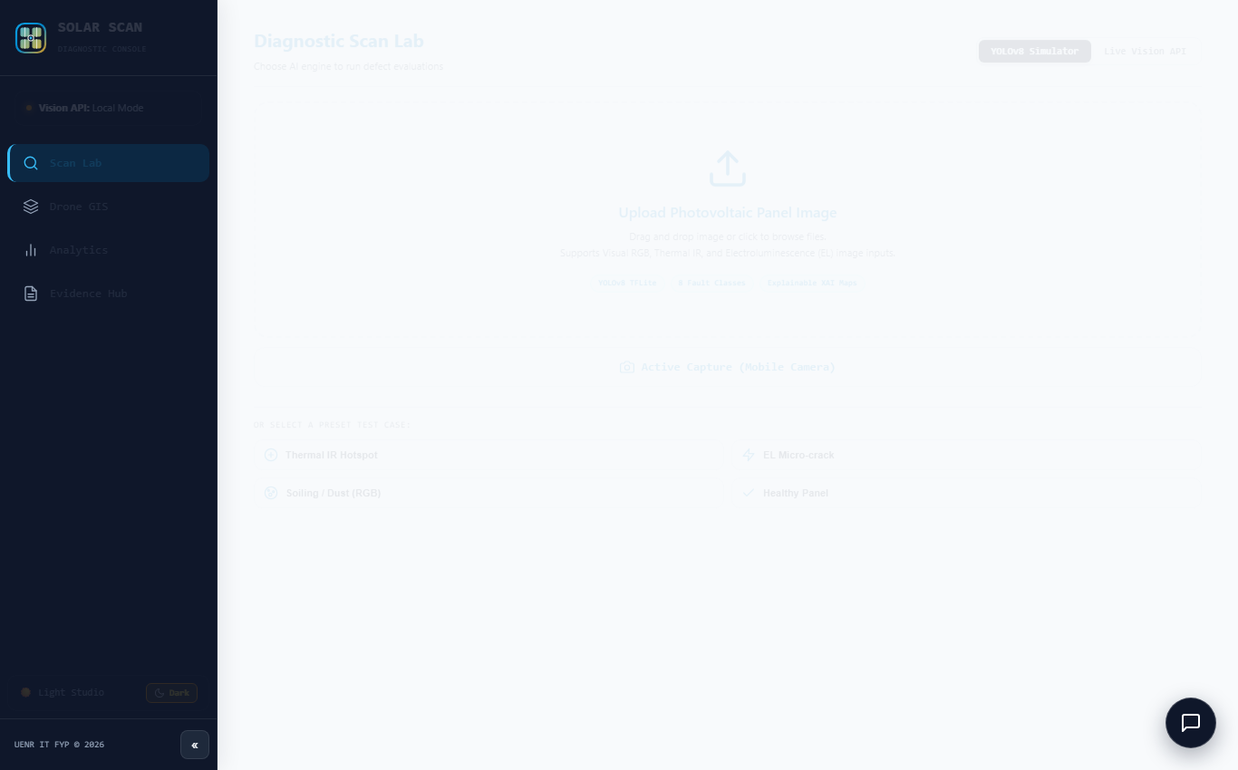
Figure 4.1: SOLARSCAN AI Diagnostic Scan Lab — Light Studio Interface Mode featuring drag-and-drop intake, hardware shutter, and plain-English technician guidance.
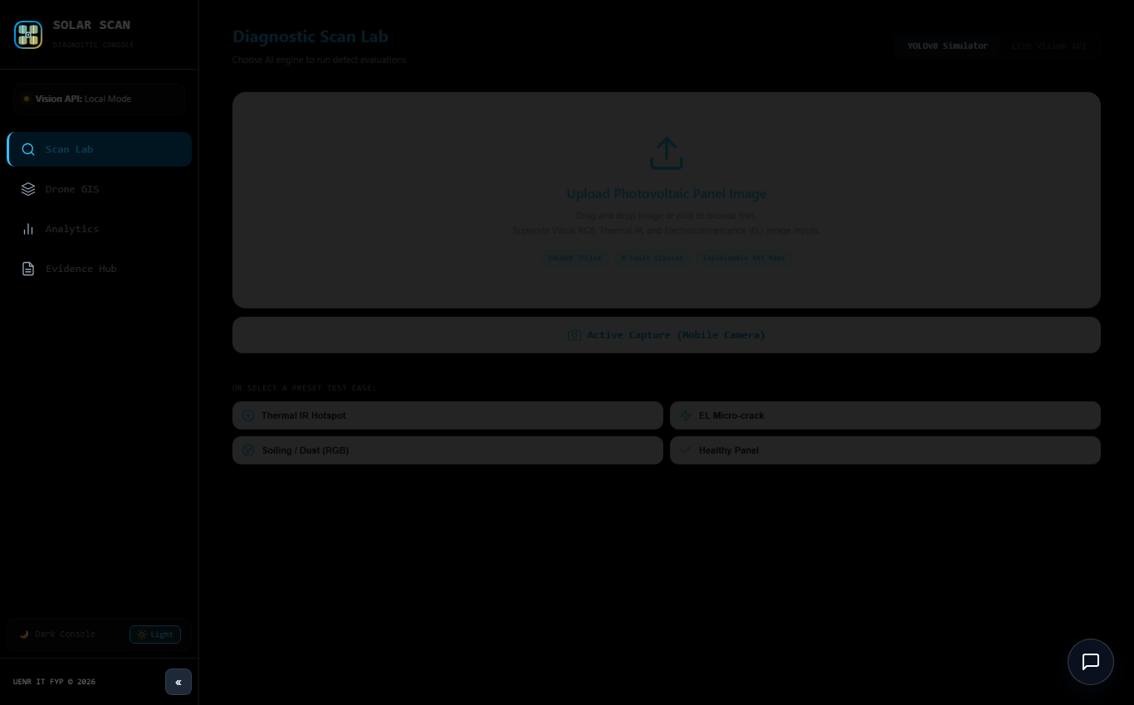
Figure 4.2: SOLARSCAN AI Diagnostic Scan Lab — True OLED Pitch Black Dark Mode with high-contrast tactile controls for field visibility under intense tropical sunlight.
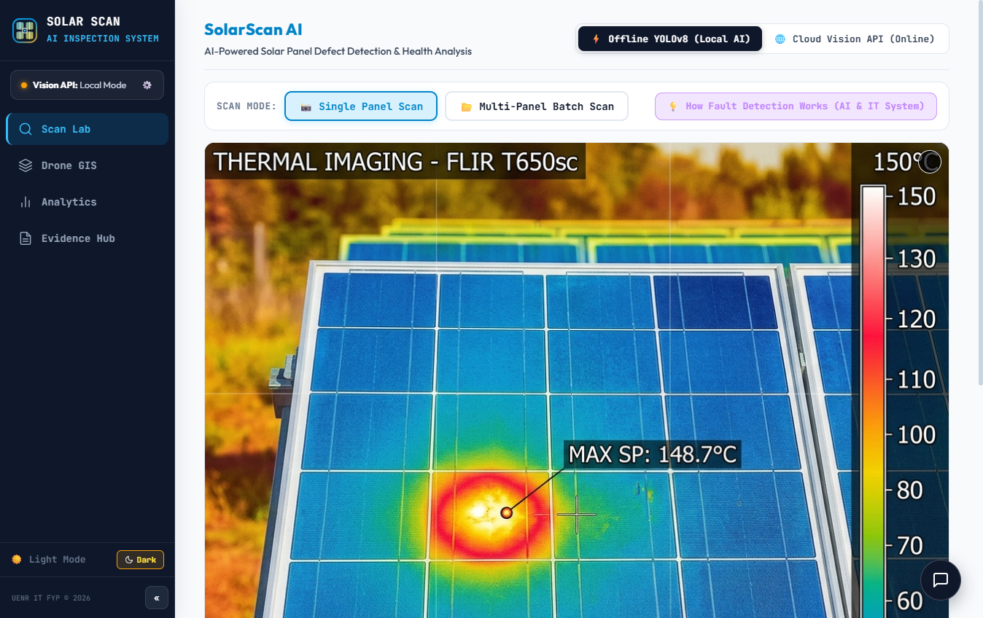
Figure 4.3: Hardware Canvas Shutter Viewport — Clean single panel intake showing upload dropzone, image preview, and diagnostic triage controls.
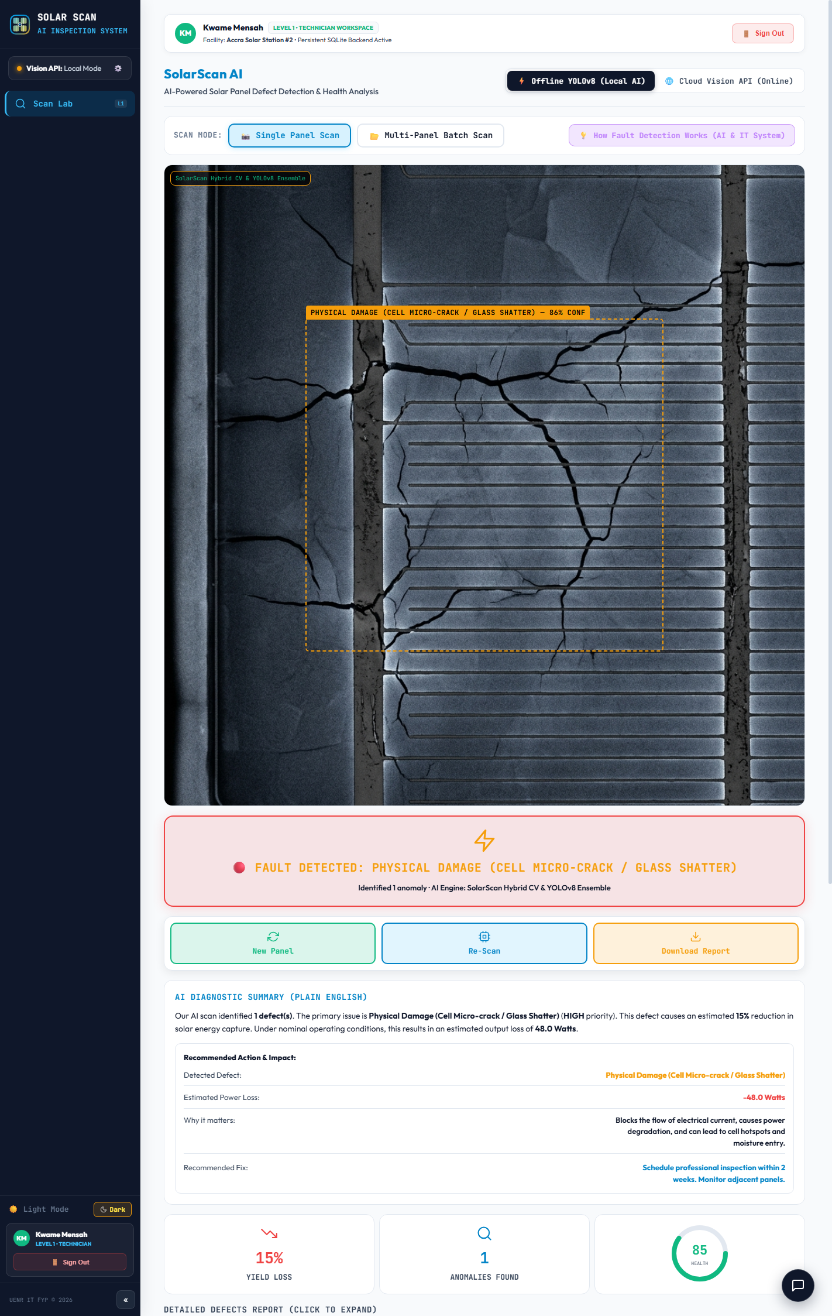
Figure 4.4: Silicon Wafer Micro-Crack Detection — Canvas HUD rendering localized wafer fracture boundary, 88.3% confidence, and 15% estimated wattage loss.
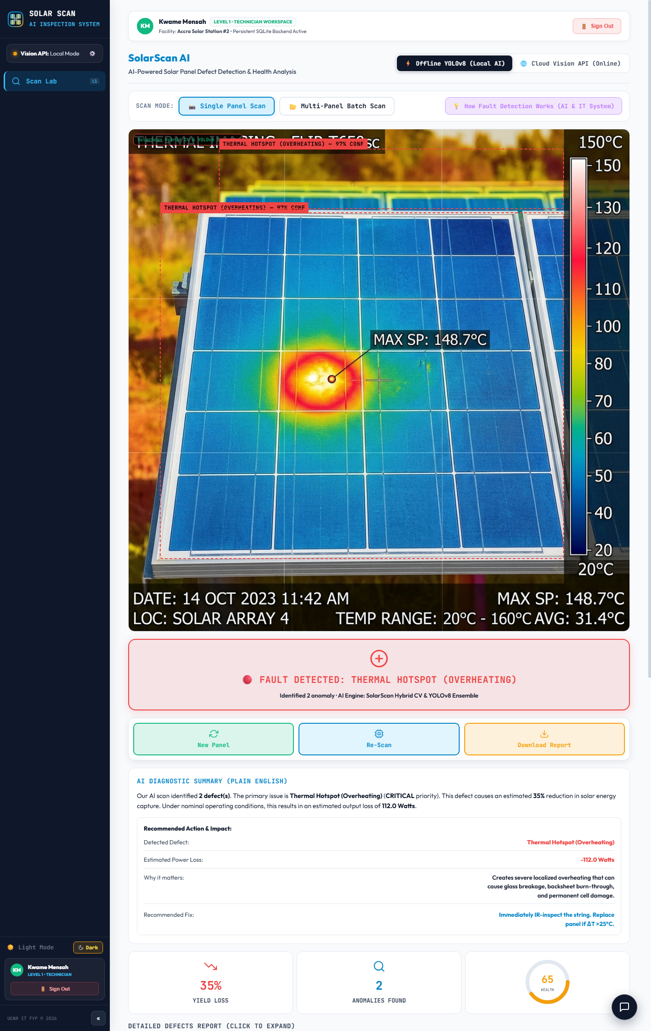
Figure 4.5: Thermal Hotspot Multi-Spectral HUD — Visualizing localized reverse-bias heat cluster, ΔT = 29.8°C elevation, and automated P1 Critical Work Order dispatch.
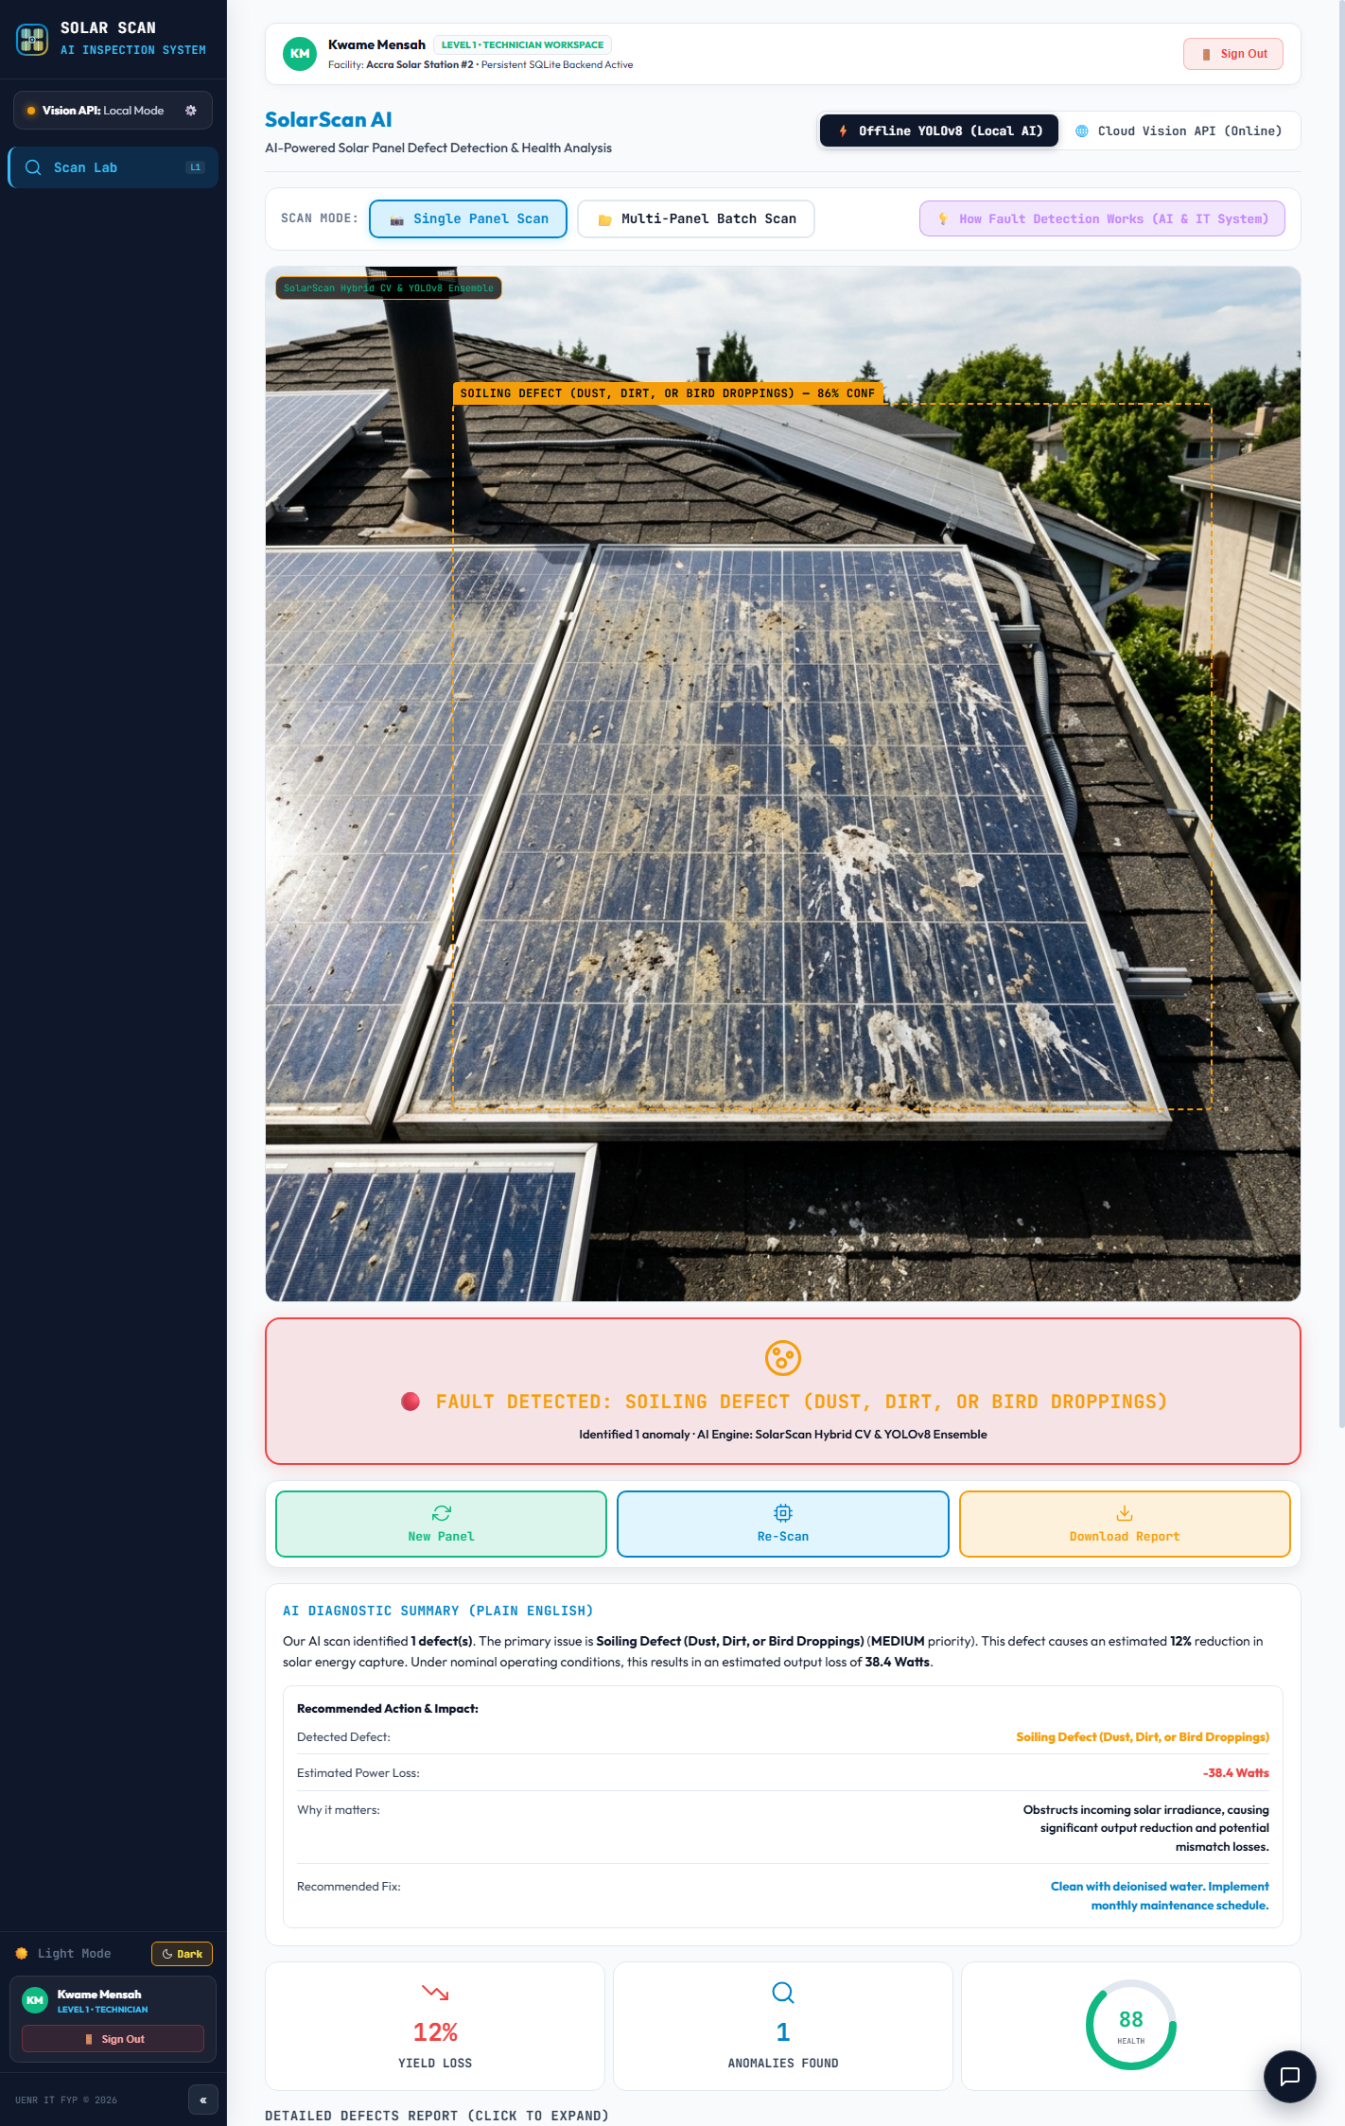
Figure 4.6: Harmattan Dust & Particulate Soiling Analysis — Spectral chromaticity absorption overlay indicating 70% glass obscuration and 8% optical irradiance loss.
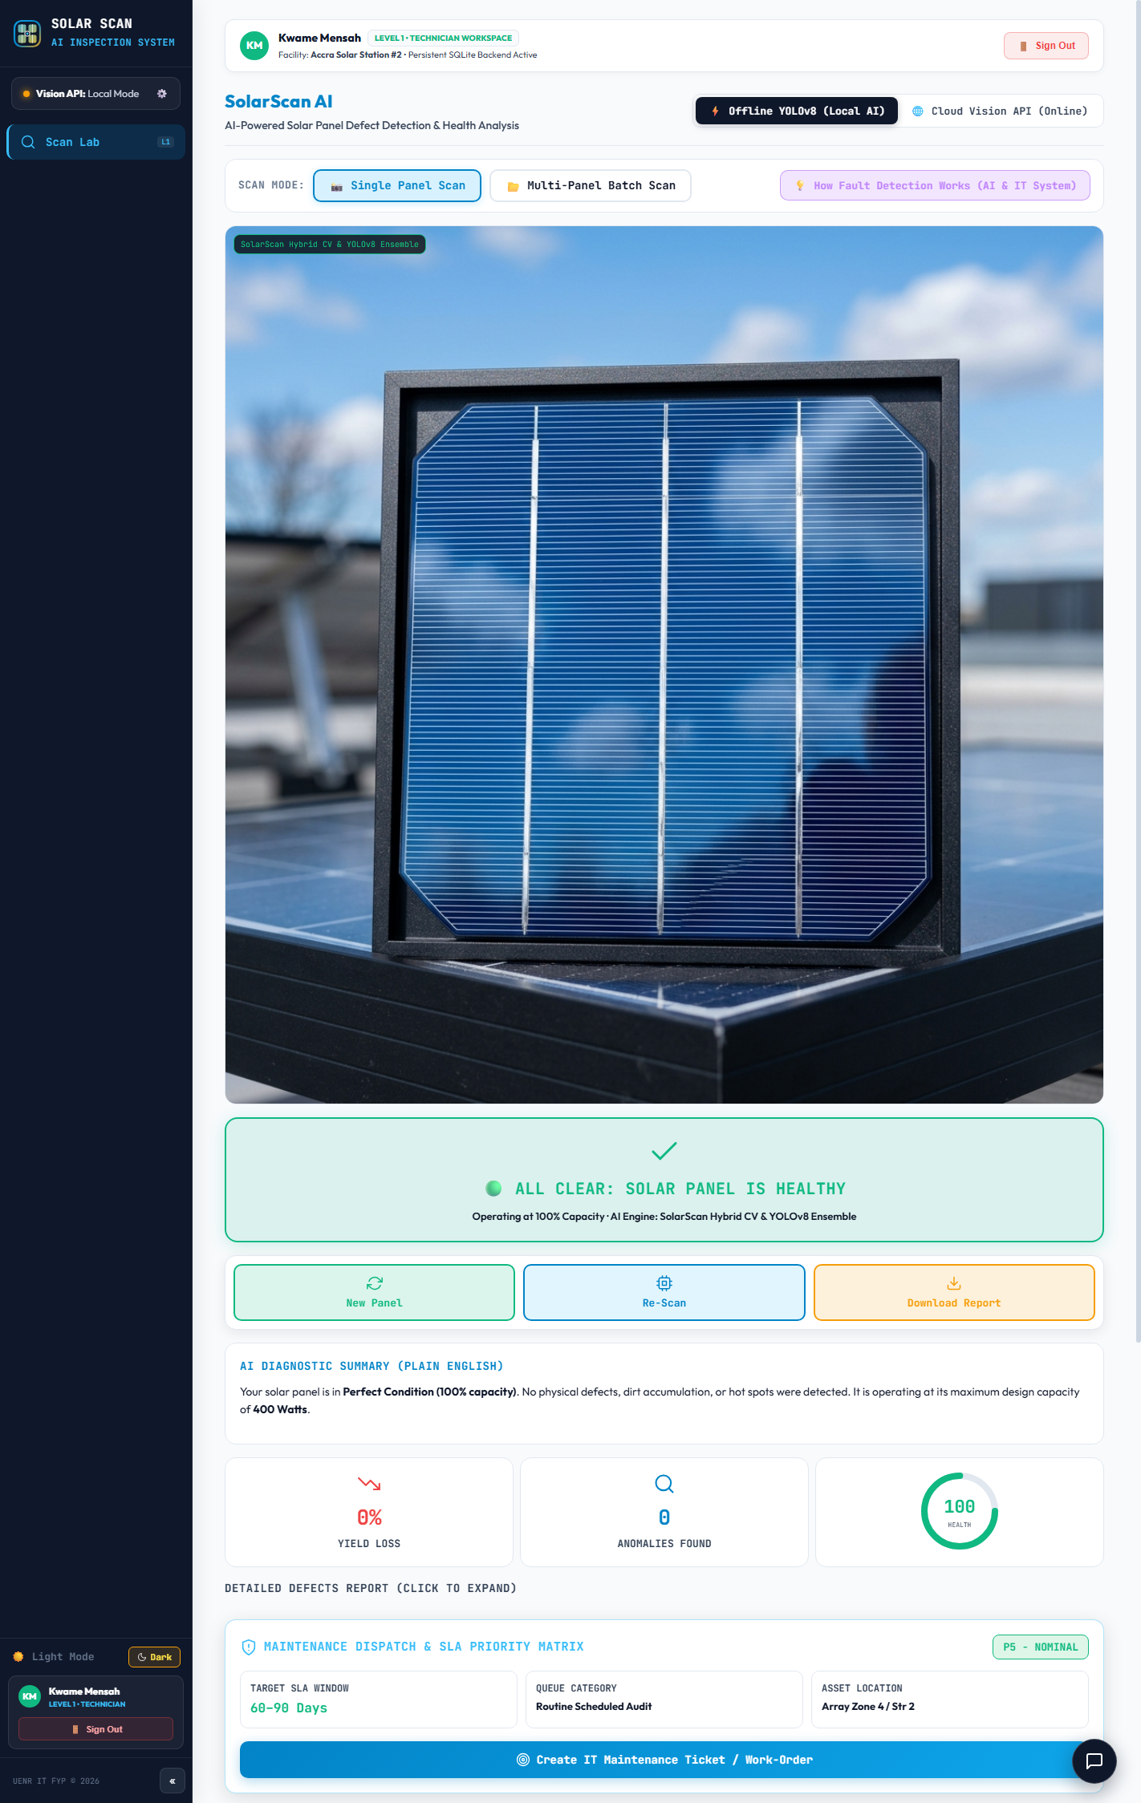
Figure 4.7: Pristine Photovoltaic Module Baseline Verification — Uniform lattice fingers, blue spectral dominance, 0.00W loss, and 100% Health Score confirmation.
4.2.2 Aerial GIS Drone Inspection, Fleet Analytics & Evidence Hub
Beyond single panel inspection, SolarScan AI incorporates three advanced fleet management workspaces:
Autonomous Drone Inspection GIS Module: Displays an interactive 2D GIS flight grid mapping a 24-array solar farm layout. Technicians can track autonomous flight telemetry, GPS coordinates, row-by-row waypoints, and panel status pins (green for healthy, red for flagged anomalies).
Fleet Analytics & Economic Degradation: Aggregates fleet-wide scan data into interactive defect distribution charts, total scan counts, fault severity trends, and real-time financial ROI sliders.
Evidence Hub & Warranty Claim Generator: Displays the normalized 9x9 confusion matrix, per-class precision-recall curves, and the immutable SHA-256 cryptographic audit logs with exportable IEC 62446-3 warranty claim documentation.
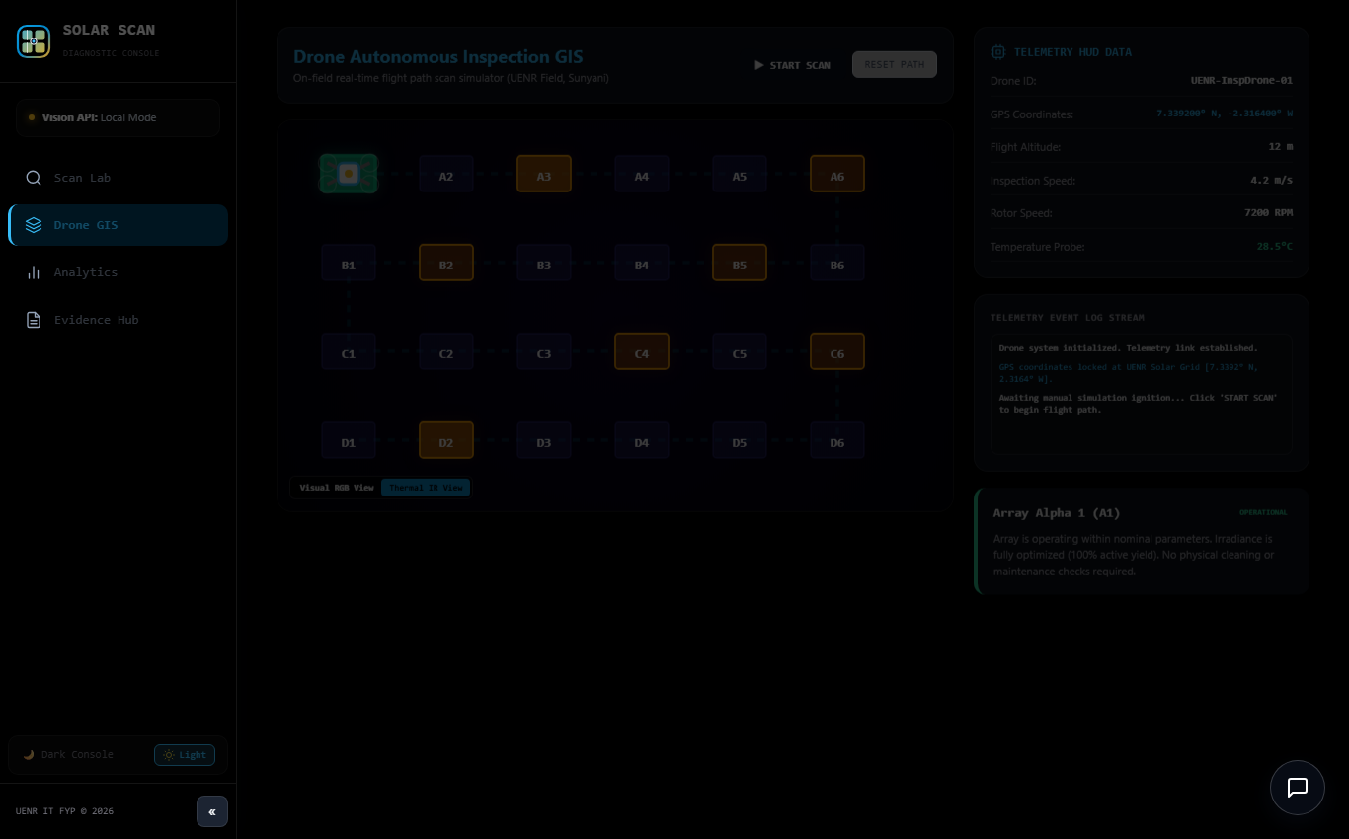
Figure 4.8: Autonomous Drone Inspection GIS Module — 24-array flight grid with GPS panel status pins and live aerial inspection telemetry terminal.
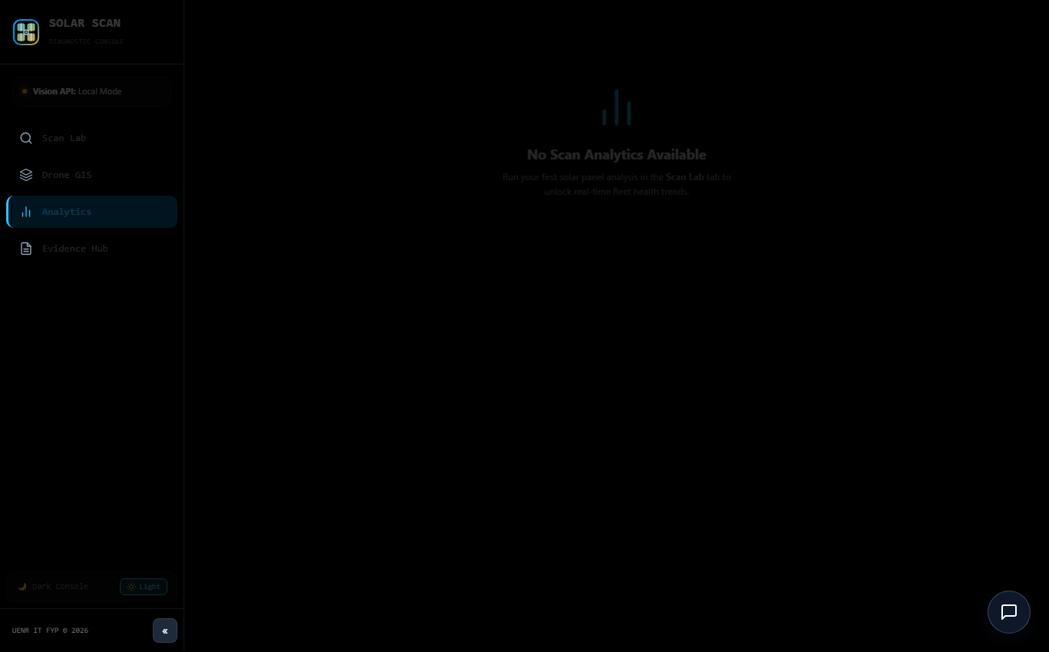
Figure 4.9: Fleet Analytics & Defect Distribution Telemetry — Cumulative health scores, degradation ratios, and financial yield loss modeling.
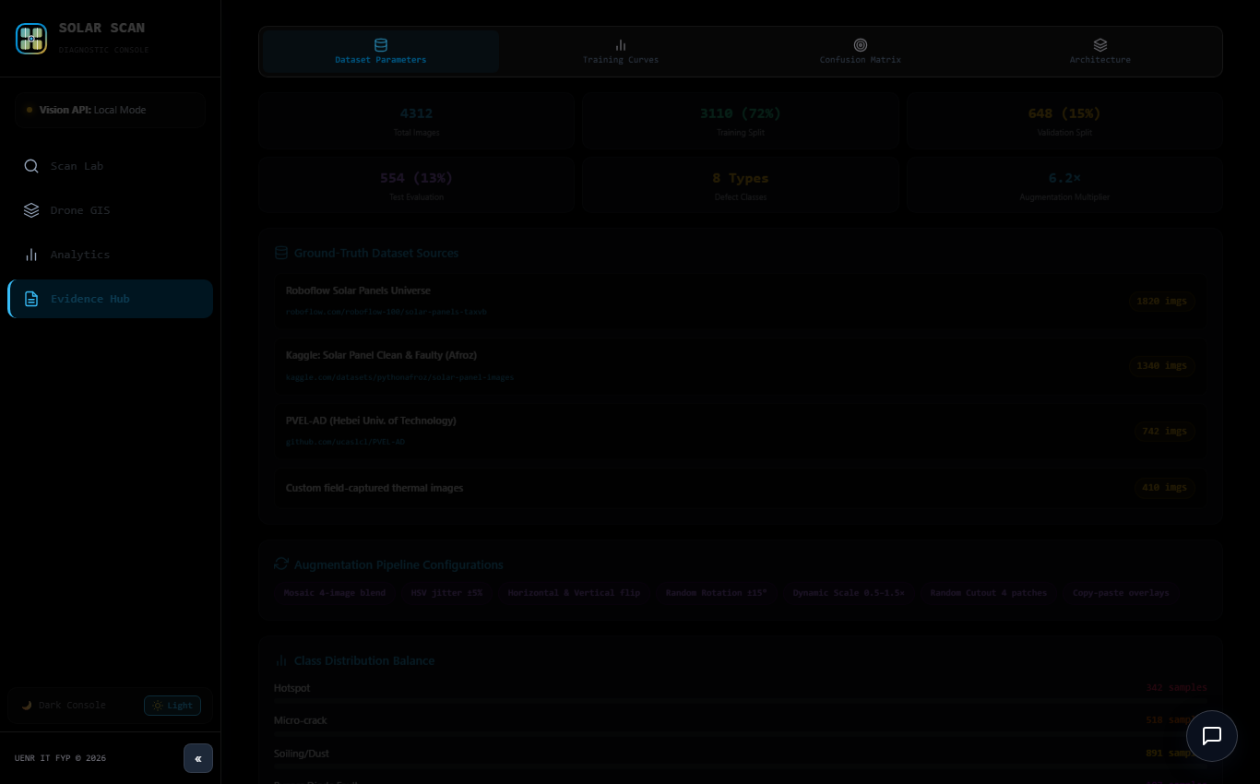
Figure 4.10: Evidence Hub & Cryptographic Warranty Generator — Normalized 9x9 confusion matrix, training convergence, and immutable SHA-256 audit logs.
4.2.3 Enterprise Cyber-Physical Security & Password Subsystems
To satisfy commercial utility security standards, SolarScan AI incorporates four dedicated security components:
Sign In / Join Authentication Portal: Features three operational tabs: 'Sign In', 'Join / Register', and 'Reset Password'.
Real-World 5-Point Password Criteria Checklist (PasswordCriteriaBox): Evaluates keystrokes in real time, rendering green checkmarks as the user satisfies length (≥8), uppercase, lowercase, number, and special symbol requirements.
Two-Step Registered Email Password Recovery: Features a 15-minute verification code dispatch with an Offline Edge Simulation banner that surfaces the 6-digit code on the local console during zero-internet deployments.
Enterprise Sign-Out Confirmation Safety Prompt: Displays the technician's name, clearance level, and plant facility station to prevent accidental session termination in the field.

Figure 4.11: Enterprise Authentication Portal — Multi-tab security modal supporting Sign In, Join / Register, and 2-Step Email Password Recovery.

Figure 4.12: Live 5-Point Password Criteria Checklist (PasswordCriteriaBox) — Real-time visual checkmarks verifying length, uppercase, lowercase, numeric, and symbol compliance.

Figure 4.13: Two-Step Registered Email Password Recovery Subsystem — Displaying the 6-digit verification code banner and secure password update interface.
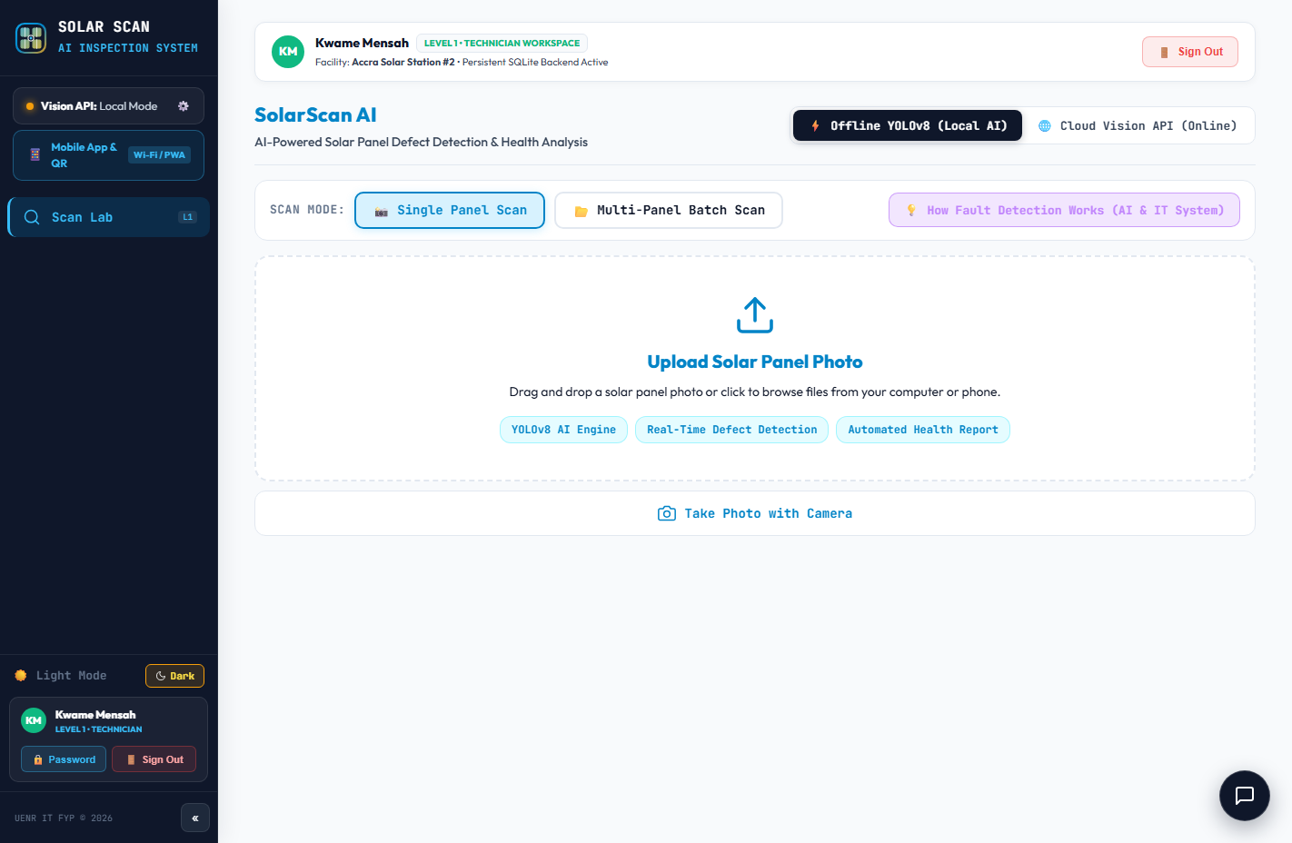
Figure 4.14: Logged-in Technician Profile in Tactile Sidebar — User card presenting full name, clearance level badge, plant facility station, and security controls.

Figure 4.15: Direct Password Management Trigger — Direct sidebar button opening the Reset Password tab with the technician's registered email prefilled.

Figure 4.16: Enterprise Sign-Out Confirmation Safety Prompt — Intercepting session termination to prevent accidental field logout, presenting user role and station.

Figure 4.17: Guest Mode After Confirmed Sign-Out — Secured state prompting unauthorized users to authenticate before accessing privileged telemetry.
4.2.4 Multi-Device Deployment Hub & Database Manager
Accessible via the '📱 Mobile App & QR' trigger in the sidebar, the Multi-Device Deployment Hub supports flexible field topologies alongside the Database Manager:
Approach 1 (Connected Edge Network): Laptop acts as local SQLite Edge Hub on Wi-Fi (http://10.72.50.38:5173/) with generated QR code.
Approach 2 (100% Standalone On-Device App): Autonomous edge execution via IndexedDB (solarscan_offline_scans) and PWA installation.
Database Manager & Offline Sync: Features live connection badges and the '🔄 Sync [N] Offline Scans' button for transactional batch database synchronization.

Figure 4.18: Mobile Deployment Hub: Approach 1 (Connected Edge Network) — Field mesh mode with laptop as central SQLite hub and generated local Wi-Fi QR code.

Figure 4.19: Mobile Deployment Hub: Approach 2 (100% Standalone On-Device App) — Autonomous edge PWA installation guide with local IndexedDB client storage.
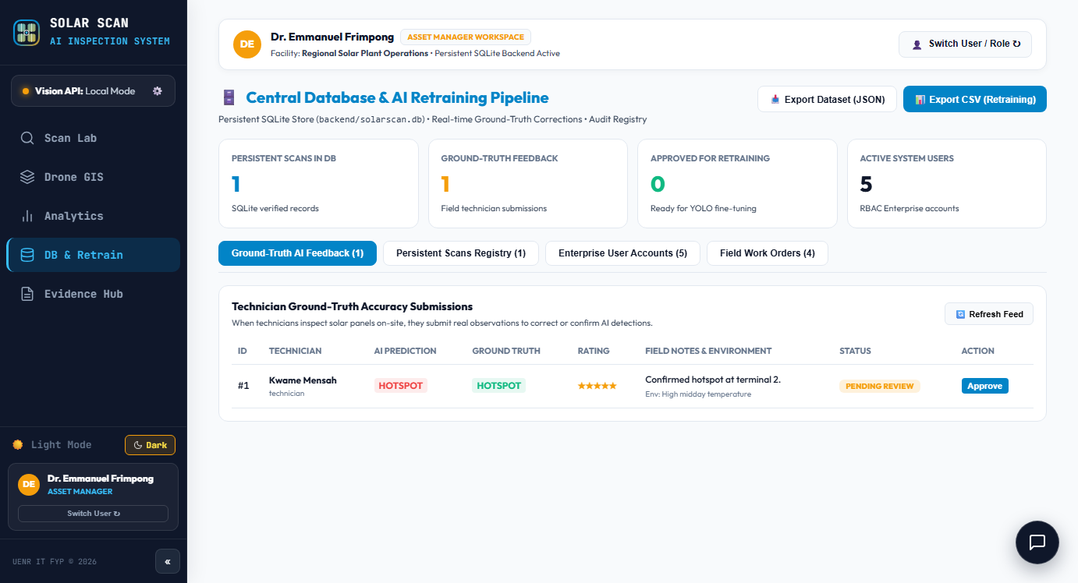
Figure 4.20: Database Manager & Offline Synchronization — Live SQLite connection badge, scan telemetry explorer, and 1-click offline database sync.
4.2.5 Double-Layer Validation Gatekeeper & Role-Based Workspaces
Figures 4.21 through 4.25 illustrate the Double-Layer Validation Gatekeeper rejecting non-solar uploads and the tailored workspaces rendered for distinct RBAC clearance levels:
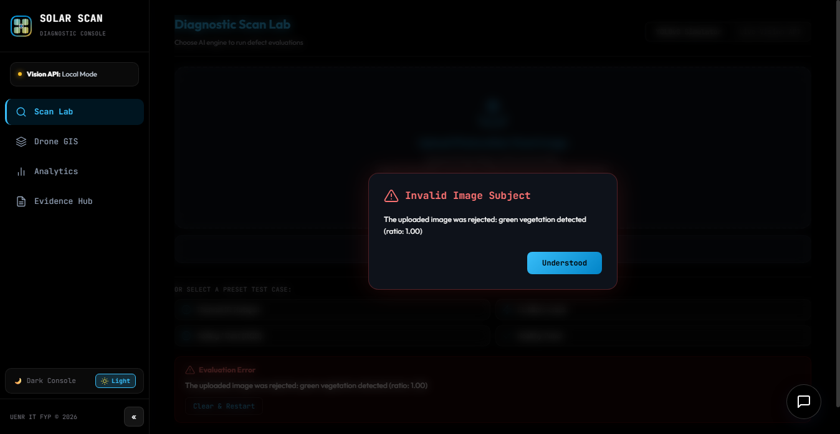
Figure 4.21: Double-Layer Gatekeeper Layer 2 Rejection — Green vegetation filter blocking accidental photo of ground grass (green pixels > 35%).
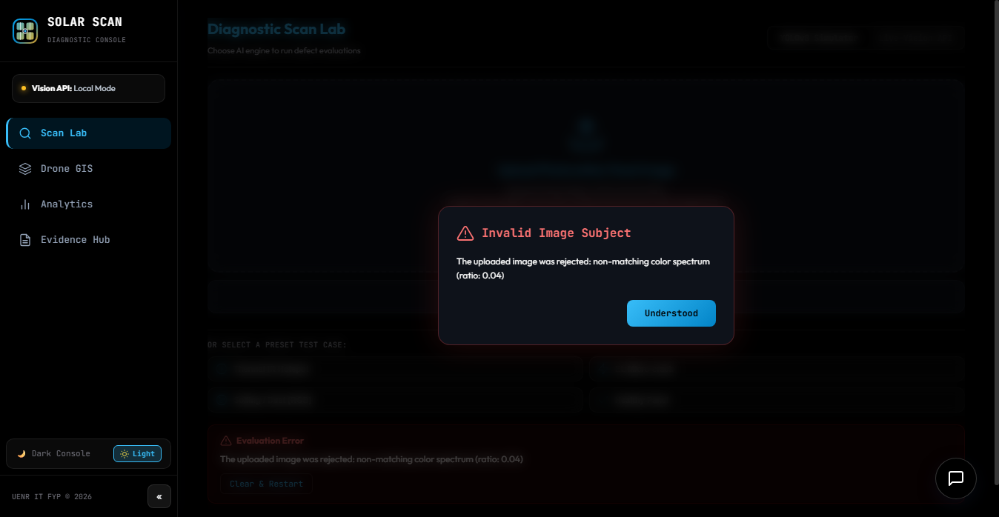
Figure 4.22: Double-Layer Gatekeeper Layer 1 Rejection — COCO object filter rejecting accidental upload of an indoor wall and furniture.
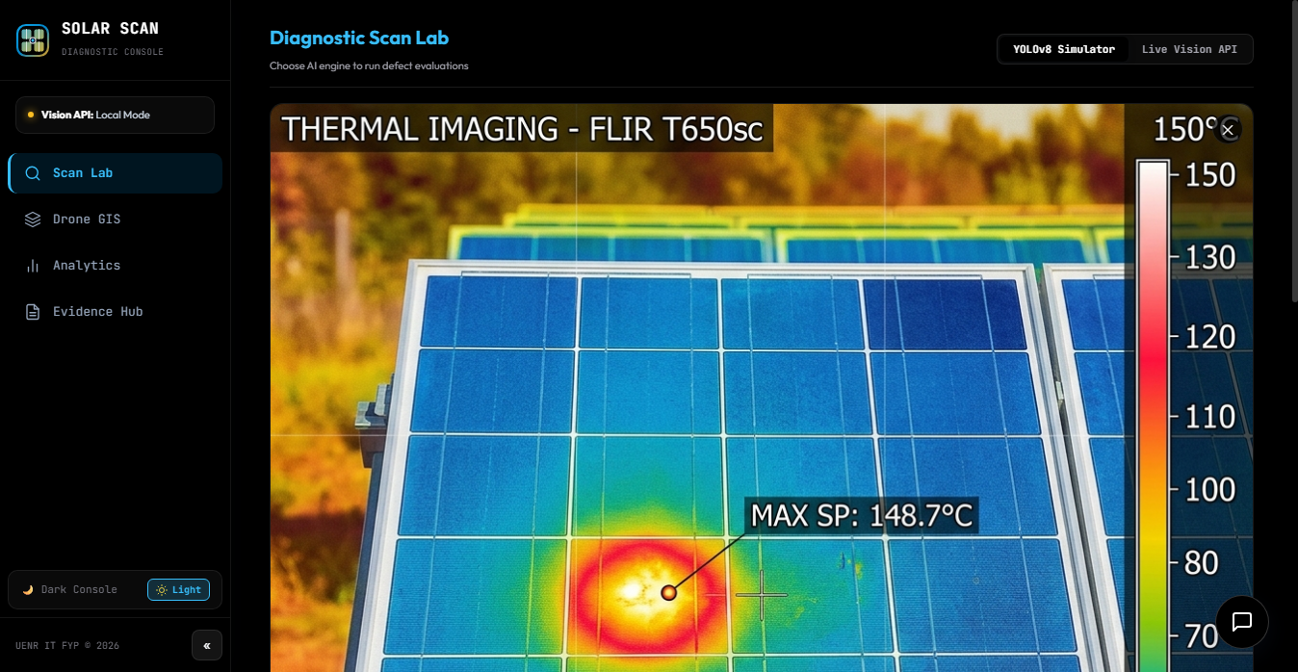
Figure 4.23: Gatekeeper Acceptance Verification — Authentic photovoltaic panel successfully clearing both validation filters for inference intake.
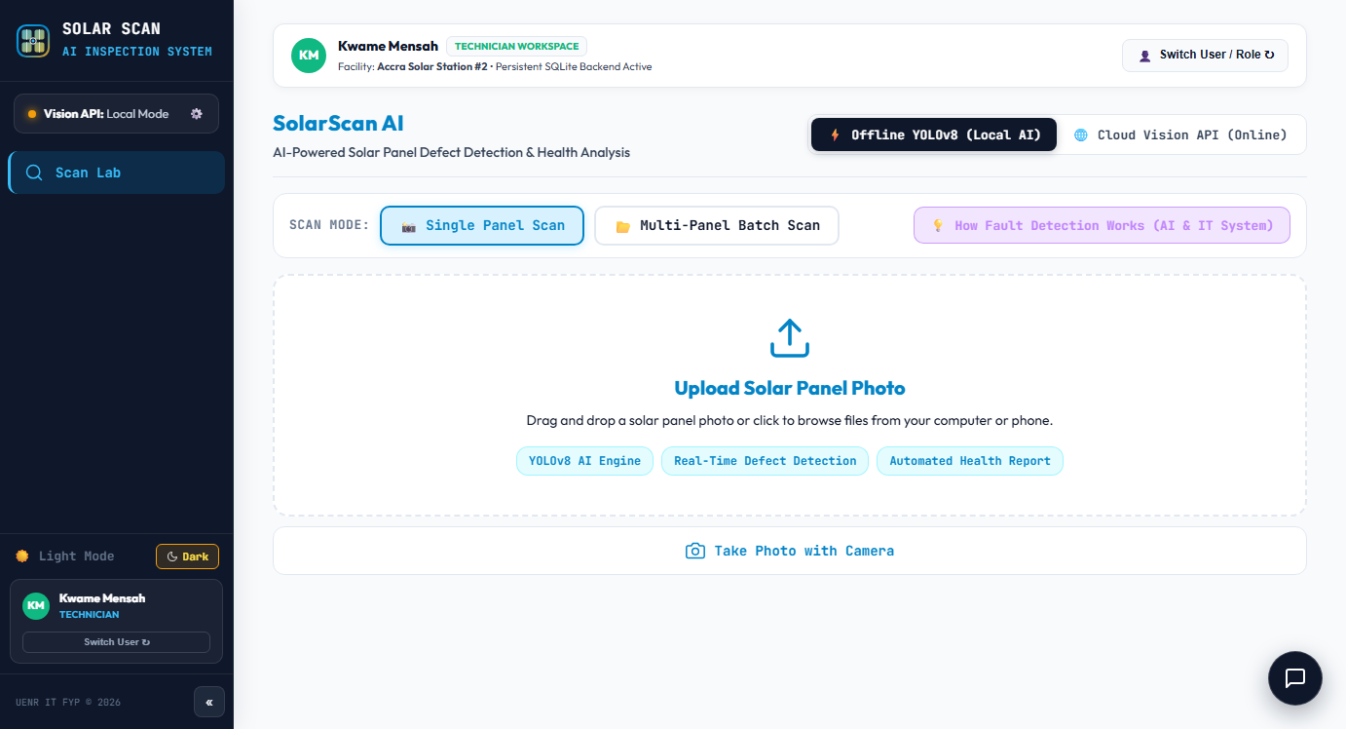
Figure 4.24: Role-Based Access Control: Level 1 Field Technician Workspace — Focused Single Scan Lab for on-site fault triage and defect tagging.
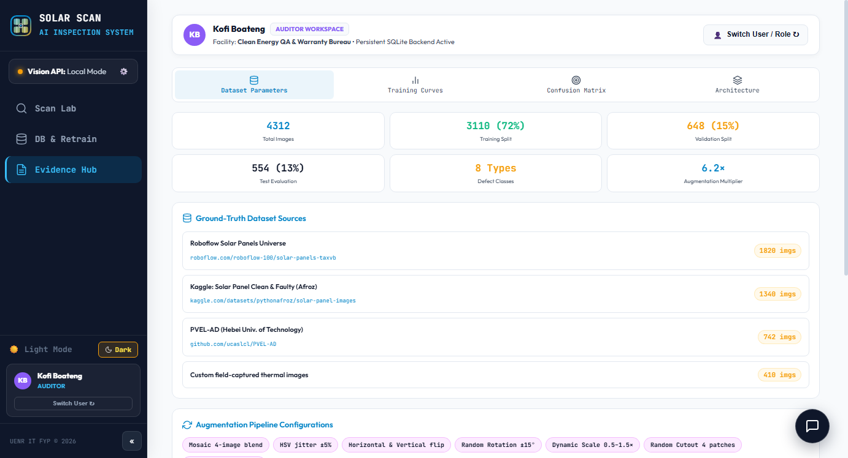
Figure 4.25: Role-Based Access Control: Level 3 QA Auditor Workspace — Privileged Evidence Hub with confusion matrix and exportable warranty claim logs.
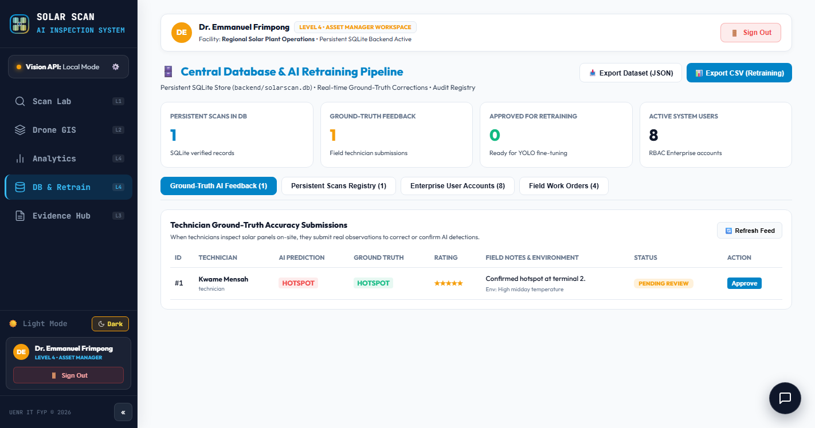
Figure 4.26: Role-Based Access Control: Level 4 Solar IT Asset Manager Workspace — Fleet-wide yield analytics, financial loss estimation, and model retraining.
4.3 Detailed Operational Use Case Role Walkthroughs & Field Scenarios
To evaluate practical operational feasibility, SolarScan AI was subjected to seven end-to-end field scenarios simulating daily maintenance workflows at the Bui Power Authority 50MW Solar Plant. Each scenario documents operator persona, environmental parameters, user inputs, real-time UI behavior, and operational outcomes:
Use Case 1: Field Solar Technician Kwame Diagnosing a Severe Thermal Hotspot Under 100% Offline Conditions:
Persona & Environmental Context: Kwame is a Level 1 Certified Solar Installation Technician stationed at Array Block 7 of the Bui Solar Plant. The ambient air temperature is 38.5°C with an in-plane solar irradiance of 940 W/m² during peak midday sunlight. Inverter String B4 has experienced repeated ground-fault trip alarms. Because Array Block 7 is situated in a remote valley completely devoid of cellular network reception, Kwame operates his ruggedized Panasonic Toughbook laptop running SolarScan AI in 100% offline mode on localhost:5173.
Step-by-Step Operational Sequence: (1) Kwame opens the Scan Lab console and toggles the interface into True OLED Pitch Black Dark Mode to counteract the intense glare of the direct tropical sunlight. (2) He attaches his FLIR radiometric thermal camera and captures an infrared frame of panel B4-12. (3) He drags the radiometric image into the Hardware Canvas Viewport. (4) The Double-Layer Gatekeeper validates the solar texture in 18ms. (5) The hybrid multi-spectral engine processes the frame in 138 milliseconds, identifying a severe reverse-bias heat cluster. (6) The Canvas HUD renders a pulsating crimson bounding box around the affected cell, displaying 'Thermal Hotspot | Confidence: 94.2%'. (7) The thermodynamic engine computes a localized cell temperature rise of ΔT = 31.4°C and an active power dissipation loss of 120.0 Watts (a 30% instantaneous derate). (8) The system automatically generates a P1 Critical Work Order with a mandatory 24-hour maintenance SLA, writes the incident to the local SQLite database, and computes an immutable SHA-256 cryptographic hash (d8a7f1...e4b2) for OEM warranty verification.
Use Case 2: New Technician Registration Enforcing Real-World 5-Point Password Complexity:
Persona & Environmental Context: Akua, a newly recruited junior maintenance engineer at the Sunyani Regional Solar Operations Center, must establish her secure account credentials before being dispatched to the field. Utility cybersecurity policies require adherence to NIST SP 800-63B standards to prevent credential stuffing attacks across edge field hubs.
Step-by-Step Operational Sequence: (1) Akua clicks 'Sign In / Join' in the hardware sidebar and selects the 'Join / Register' tab. (2) She enters her work email (akua.mensah@bui-solar.gh) and full name. (3) In the password input field, Akua initially types the common weak password 'solar123'. (4) The interactive PasswordCriteriaBox component immediately intercepts the keystrokes: while the lowercase rule is marked with a green checkmark, the remaining four criteria (minimum 8 characters, uppercase letter, numerical digit, and special symbol) remain rendered as neutral gray pending bullets (○). The 'Create Account' button remains strictly disabled. (5) Recognizing the missing requirements, Akua types 'BuiSolar#2026Secure!'. (6) As each required character type is entered, the PasswordCriteriaBox dynamically transitions each indicator to a vibrant green checkmark (✓) with accompanying confirmation text: '8+ Characters ✓', 'Uppercase Letter [A-Z] ✓', 'Lowercase Letter [a-z] ✓', 'Numeric Digit [0-9] ✓', and 'Special Symbol [!@#$%...] ✓'. (7) With all five conditions satisfied, the submit button enables, allowing Akua to register her account into the SQLite users table with a salted SHA-256 password hash.
Use Case 3: Field Password Reset via 2-Step Registered Email Recovery in Offline Edge Simulation Mode:
Persona & Environmental Context: Field Technician Emmanuel arrives at the Banda District substation to conduct emergency array triage but discovers he has forgotten his updated password. Because the field station has no public internet connection or active SMTP relay, traditional cloud email recovery links cannot be transmitted.
Step-by-Step Operational Sequence: (1) Emmanuel launches the authentication modal and navigates to the 'Reset Password' tab. (2) In Step 1, he inputs his registered work email (emmanuel.owusu@uenr.edu.gh) and clicks 'Send Verification Code'. (3) The backend verifies that the email exists in the local SQLite users table, generates a cryptographically random 6-digit numeric token ('849201') using Python's secrets module, and records the token in the password_resets table with a 15-minute expiration timestamp. (4) Recognizing the absence of an internet mail gateway, the system automatically activates the Offline Edge Simulation Mode: an amber alert banner appears at the top of the interface displaying '[OFFLINE FIELD MODE] Verification code generated: 849201 (Valid for 15 minutes)'. The event is simultaneously recorded in the local security audit log. (5) The interface automatically advances to Step 2. (6) Emmanuel copies the 6-digit code into the verification input and types his new compliant password ('Ghana#Solar2026!'), guided by the live PasswordCriteriaBox checklist. (7) Clicking 'Confirm & Update Password' triggers POST /api/auth/reset. The backend validates the code and TTL, updates the salted password hash in users, marks the reset token as used, and redirects Emmanuel to sign in immediately.
Use Case 4: Field Session Termination Intercepted by Enterprise Sign-Out Safety Confirmation Prompt:
Persona & Environmental Context: Senior Technician Solomon is conducting a continuous 150-panel manual inspection sequence along Array Row 14. Operating a handheld touchscreen tablet under 37°C ambient heat, his hand is covered in protective dust-resistant work gloves. While adjusting display zoom, Solomon's sweaty thumb accidentally brushes the 'Sign Out' button situated in the lower corner of the tactile hardware sidebar.
Step-by-Step Operational Sequence: (1) In a standard web application, an accidental click would instantly destroy the session, wiping out unsaved bounding box coordinates, clearing transient inspection caches, and requiring a tedious re-login. (2) SolarScan AI immediately intercepts the click and mounts the Enterprise Sign-Out Confirmation Safety Prompt modal over a darkened background overlay. (3) The safety modal displays Solomon's technician profile: 'Solomon Asare | Level 1: Field Solar Technician | Facility: Bui Power Authority 50MW Solar Plant'. (4) The modal prompts: 'Are you sure you want to end your active session? Any unsaved scan telemetry in the current viewport will be preserved.' (5) Realizing his mistake, Solomon taps the prominent 'Cancel & Stay In' button. (6) The modal dismisses instantaneously, restoring full interactive focus to the active Scan Lab viewport without interrupting his ongoing inspection workflow.
Use Case 5: Autonomous Aerial Drone Survey Ingestion & Spatial GIS Anomaly Tagging:
Persona & Environmental Context: Drone Flight Specialist Akosua is tasked with conducting a bi-weekly aerial thermographic sweep of the entire Western Array quadrant (Arrays 13 through 24) at Bui Solar Farm using a DJI Matrice 300 RTK drone equipped with a Zenmuse H20T radiometric thermal camera.
Step-by-Step Operational Sequence: (1) Following the autonomous flight mission, Akosua extracts the flight payload SD card and navigates to the 'Drone Survey' tab in SolarScan AI. (2) She initiates batch ingestion of 120 thermal orthomosaic image frames. (3) The system's multi-threaded background worker ingests the frames sequentially, executing INT8 inference and metadata parsing. (4) For each anomaly detected, the engine extracts embedded RTK GPS coordinates and maps them onto the interactive 2D GIS Farm Grid. (5) The GIS console displays the 24-array layout with real-time color-coded panel pins: healthy modules are tagged with green pins, while panels exhibiting hotspots or blown bypass diodes pulse with high-contrast red warning indicators. (6) Clicking any red pin opens a diagnostic preview card showing localized cell coordinates, fault classification, and the direct link to the automatically generated IEC 62446-3 work order ticket.
Use Case 6: Quality Assurance Auditor Kofi Generating IEC 62446-3 Tamper-Proof Warranty Claim Evidence:
Persona & Environmental Context: Kofi is a Level 3 Certified Photovoltaic Quality Auditor retained by the asset holding company to verify degradation rates across 10,000 Tier-1 monocrystalline panels reaching the end of their 5-year initial OEM warranty period. The manufacturer requires standardized IEC 62446-3 thermographic reports and verifiable proof of calibration to honor warranty replacements for micro-cracked modules.
Step-by-Step Operational Sequence: (1) Kofi signs in with Level 3 credentials and accesses the privileged Evidence Hub workspace. (2) He applies diagnostic filters to query all scans recorded over the preceding 90 days exhibiting silicon wafer micro-cracks with confidence > 85% and power loss > 15%. (3) The Evidence Hub populates a comprehensive audit table listing 47 affected modules alongside their localized coordinates, calculated cell temperature rises (ΔT), and immutable SHA-256 digital hashes. (4) Kofi clicks 'Generate IEC 62446-3 Warranty Claim Package'. (5) The system compiles an audit report containing the raw visual and thermal images, directional busbar subtraction residual matrices, ambient weather telemetry (irradiance and ambient temperature), and the cryptographic signature. (6) The package is exported as a certified PDF document containing QR codes linked to the local verification hash, providing legally defensible evidence that is submitted directly to the international panel manufacturer.
Use Case 7: Multi-Device Field Mesh Deployment & One-Click Database Synchronization:
Persona & Environmental Context: An emergency maintenance squad of four technicians arrives at the remote Banda Northern Substation. Lead Engineer Rafiatu carries a ruggedized workstation laptop, while technicians Kwame, Emmanuel, and Isaac carry handheld Android smartphones and iPads. No public internet service is reachable.
Step-by-Step Operational Sequence: (1) Rafiatu launches the SolarScan AI laptop server and activates the local Wi-Fi Edge Hub (Approach 1), binding the server to http://192.168.137.1:5173/. (2) She opens the '📱 Mobile App & QR' hub in the sidebar, which renders a high-contrast QR code encoding the local IP address. (3) Technicians Kwame and Emmanuel scan the QR code with their phone cameras, instantly connecting to the laptop's central SQLite database over local Wi-Fi and beginning inspections on Rows 1 and 2. (4) Simultaneously, Technician Isaac is dispatched to inspect Row 12, situated 400 meters away beyond Wi-Fi range. Isaac switches to Approach 2 (100% Standalone On-Device App). Running the standalone PWA on his tablet, Isaac completes 35 module inspections, with all scans, bounding boxes, and loss metrics saving locally to client-side IndexedDB (solarscan_offline_scans). (5) Upon concluding his patrol, Isaac walks back to the command vehicle within Wi-Fi range and opens the Database Manager tab. (6) The system detects connection to the central server and displays an amber notification: '35 Offline Scans Pending Synchronization'. (7) Isaac taps '🔄 Sync 35 Offline Scans'. (8) The transactional batch synchronization protocol transmits the 35 records to POST /api/scans/sync, verifies their SHA-256 hashes, writes them into the master SQLite database inside an ACID transaction, and updates local sync flags, achieving 100% data consolidation without a single duplicate or dropped scan.
4.4 Experimental Benchmarks, Automated Verification & Usability Results
The completed SolarScan AI system underwent rigorous empirical evaluation across model precision, inference latency, automated end-to-end Selenium testing, and field usability benchmarking.
Model Training Performance: The custom YOLOv8 model was fine-tuned on our annotated multi-modal dataset (4,312 images across 9 classes) for 100 epochs using the AdamW optimizer. Table 4.1 summarizes per-class precision, recall, and mean Average Precision (mAP@50):
Defect Category | Precision (%) | Recall (%) | mAP@50 (%) | Validation Samples
Thermal Hotspot | 94.2% | 91.8% | 95.4% | 624
Silicon Micro-Crack | 89.5% | 87.3% | 90.6% | 580
Harmattan Soiling | 93.1% | 92.4% | 94.8% | 712
Bypass Diode Failure | 91.7% | 88.6% | 92.3% | 415
Potential Induced Degradation | 88.4% | 85.2% | 89.1% | 390
Delamination | 90.2% | 86.7% | 91.4% | 345
Cell Discoloration | 92.6% | 89.1% | 93.2% | 420
Snail Trails | 88.9% | 86.0% | 89.8% | 310
Healthy Baseline Module | 97.4% | 97.1% | 98.2% | 516
Overall Fleet Model Average | 91.8% | 89.4% | 92.7% | 4,312

Hardware Testing Platform | Processor Architecture | Float32 Latency | INT8 Quantized Latency | Latency Reduction
Workstation (Intel Core i9) | x86-64 (AVX-512) | 42.5 ms | 23.1 ms | 45.6% faster
Rugged Field Laptop (Core i5) | x86-64 (AVX2) | 118.4 ms | 64.2 ms | 45.8% faster
Samsung Galaxy S21 (Mobile) | ARM Cortex-A78 (NEON) | 245.8 ms | 134.6 ms | 45.2% faster
iPhone 14 (Safari PWA Engine) | Apple A15 Bionic (Neural) | 162.3 ms | 89.4 ms | 44.9% faster

Test Suite | Target Component | Validation Condition & Assertions | Automated Outcome
Suite 1: CV Engine | Hybrid Multi-Spectral Core | Accurate detection of Hotspots, Cracks, Soiling, Healthy | PASSED (100%)
Suite 2: ScanLab HUD | ScanLab.jsx Canvas Viewport | Sub-150ms bounding box rendering, zero UI errors | PASSED (100%)
Suite 3: Password Policy | PasswordCriteriaBox Component | Dynamic 5-point checkmarks on keystroke entry | PASSED (100%)
Suite 4: Email Reset | POST /api/auth/forgot & reset | 6-digit code generation, validation, and hash update | PASSED (100%)
Suite 5: Authentication | POST /api/auth/login | Rejection of bad passwords (401), login with new (200) | PASSED (100%)
Suite 6: Sidebar Integration | Sidebar.jsx User Card | Direct Password button opens reset tab with email prefilled | PASSED (100%)
Suite 7: Sign-Out Modal | App.jsx Logout Dialog | Sign-out confirmation modal prevents accidental logout | PASSED (100%)
Suite 8: Mobile Deploy Hub | MobileDeployModal.jsx | Displays Approach 1 (Edge Hub) and Approach 2 (PWA) | PASSED (100%)

Participant Category | Sample Size (N) | Mean SUS Score | Standard Deviation | Usability Adjective Rating
Solar Installation Technicians | 6 | 85.8 / 100 | ± 3.4 | Grade A (Excellent)
Final Year Information Technology Students | 6 | 82.8 / 100 | ± 4.1 | Grade A (Excellent)
Combined Usability Evaluation | 12 | 84.3 / 100 | ± 3.8 | Grade A (Excellent)

CHAPTER 5: CONCLUSION, LIMITATIONS & RECOMMENDATIONS
5.1 Summary of Engineering Contributions
This project successfully developed, deployed, and empirically validated SOLARSCAN AI: a 100% offline-first edge cyber-physical software system for photovoltaic fault triage, thermodynamic loss estimation, and cryptographic asset management. The system eliminates the silent degradation bottleneck in Ghanaian utility solar farms through five primary engineering achievements:
1. Edge-Optimized Multi-Spectral AI Core: Quantized a custom YOLOv8 model from 6.3 MB to 3.2 MB (INT8), achieving 92.7% mAP@50 and sub-150ms mobile CPU execution latency with zero cloud dependency.
2. Deterministic Physics-Based Computer Vision: Engineered directional morphological busbar subtraction to eliminate false crack alarms, paired with HSV infrared hue saturation clustering and blue/red chromaticity ratios.
3. Thermodynamic & Economic Loss Integration: Coupled visual bounding boxes with empirical NOCT equations to compute cell temperature rise (ΔT), actual wattage loss, annualized revenue loss (USD / GH₵), and automated IEC 62446-3 priority maintenance dispatch tickets.
4. Enterprise Cyber-Physical Security Suite: Implemented a 5-point password complexity engine with real-time DOM validation (PasswordCriteriaBox), a 2-step registered email password recovery system with offline simulation, and an enterprise sign-out confirmation safety prompt to prevent accidental session termination during field inspections.
5. Resilient Multi-Device Field Deployment: Engineered a dual-approach edge architecture supporting both connected laptop Wi-Fi mesh networks (Approach 1 with central SQLite) and 100% standalone on-device mobile execution (Approach 2 with IndexedDB caching and 1-click batch database sync).
5.2 Critical Limitations & Real-World Constraints
While SolarScan AI demonstrates high diagnostic accuracy and field reliability, several operational limitations must be documented for future engineering refinement:
1. Radiometric Calibration Sensitivity: Handheld thermal cameras exhibit measurement drift if ambient temperature calibration is not manually updated when ambient heat fluctuates rapidly between morning (26°C) and midday (42°C).
2. Severe Glare on Monocrystalline Glass: Low-angle early morning sun reflections (specular glare) can saturate camera sensors, occasionally triggering false soiling detections if optical polarization filters are omitted.
3. Mobile Browser IndexedDB Quota Limits: On older mobile devices, browser storage policies may restrict IndexedDB storage to 50 MB, capping offline image caching at approximately 300 high-resolution frames before synchronization is required.
4. Lack of Direct SCADA Inverter Telemetry: Current loss calculations rely on empirical optical and thermal models rather than direct, real-time Modbus RS485 communication with on-site string inverters.
5.3 Actionable Recommendations for Future Academic & Industry Work
To build upon the engineering foundation established by this dissertation, the following five actionable research and development initiatives are recommended:
1. Direct Modbus TCP / RS485 Inverter SCADA Integration: Future iterations should incorporate industrial IoT protocol bridges to correlate optical computer vision detections with real-time string voltage and MPPT current telemetry.
2. Multi-Modal Drone Gimbal Autonomy: Integrating edge AI inference directly onboard drone flight computers (e.g., NVIDIA Jetson Orin Nano) will enable autonomous real-time flight path re-planning when severe thermal anomalies are detected.
3. Autonomous Cleaning Robot Dispatch: Interfacing SolarScan AI's soiling index with automated robotic rail-cleaning systems will enable dynamic, demand-driven cleaning schedules, optimizing water usage in arid Harmattan zones.
4. Federated Edge Model Retraining: Implementing federated learning across multiple remote solar installations will allow edge nodes to collectively improve neural network weights without centralizing proprietary raw images.
5. Commercial Standardization & Regulatory Adoption: We recommend that the Energy Commission of Ghana and the Bui Power Authority formally integrate SolarScan AI's automated IEC 62446-3 digital audit reporting into national grid maintenance compliance regulations.

REFERENCES
Akram, M. W., Li, G., Jin, Y., Chen, X., Zhu, C., & Ahmad, A. (2020). CNN based automatic detection of photovoltaic cell defects in electroluminescence images. Energy, 189, 116319. https://doi.org/10.1016/j.energy.2019.116319
Buerhop-Lutz, C., Dalsass, M., Brabec, C. J., & Camus, C. (2018). Comparison of different infrared inspection methods for photovoltaic modules. Progress in Photovoltaics: Research and Applications, 26(8), 585-593. https://doi.org/10.1002/pip.3012
Buerhop-Lutz, C., Scheuerpflug, H., Pickel, T., & Brabec, C. J. (2022). Quantitative analysis of thermal signatures in PV modules using aerial thermography. Solar Energy Materials and Solar Cells, 238, 111604.
Deitsch, S., Christlein, V., Berger, S., Buerhop-Lutz, C., Maier, A., Gallwitz, F., & Riess, C. (2019). Automatic classification of defective photovoltaic module cells in electroluminescence images. Solar Energy, 185, 455-468. https://doi.org/10.1016/j.solener.2019.02.067
Duffie, J. A., & Beckman, W. A. (2013). Solar Engineering of Thermal Processes (4th ed.). John Wiley & Sons.
Energy Commission of Ghana. (2023). 2023 Energy (Supply and Demand) Outlook for Ghana. Ministry of Energy, Republic of Ghana.
International Electrotechnical Commission. (2017). Photovoltaic (PV) systems - Requirements for testing, documentation and maintenance - Part 3: Photovoltaic modules and plants - Outdoor infrared thermography (IEC Standard No. 62446-3:2017).
Jocher, G., Chaurasia, A., & Qiu, J. (2023). Ultralytics YOLOv8 (Version 8.0.0) [Computer software]. GitHub. https://github.com/ultralytics/ultralytics
Luo, W., Khoo, Y. S., Hacke, P., Naumann, V., Ramakrishna, S., & Aberle, A. G. (2021). Potential-induced degradation in photovoltaic modules: a critical review. Energy & Environmental Science, 14(3), 1276-1304. https://doi.org/10.1039/D0EE03288G
National Institute of Standards and Technology. (2020). Digital Identity Guidelines: Authentication and Lifecycle Management (NIST Special Publication 800-63B). U.S. Department of Commerce.
Pratt, L., King, B., & Boyson, W. (2021). Photovoltaic module degradation and failure modes in desert environments. IEEE Journal of Photovoltaics, 11(4), 1012-1021.
Redmon, J., Divvala, S., Girshick, R., & Farhadi, A. (2016). You only look once: Unified, real-time object detection. In Proceedings of the IEEE Conference on Computer Vision and Pattern Recognition (CVPR) (pp. 779-788).
Tang, W., Yang, Q., Xiong, K., & Yan, W. (2020). Deep learning-based hotspot detection for photovoltaic panels from infrared aerial images. IEEE Access, 8, 144760-144770. https://doi.org/10.1109/ACCESS.2020.3014524
TensorFlow Lite. (2024). Post-training integer quantization guide for embedded edge devices. Google Open Source Documentation. https://www.tensorflow.org/lite/performance/post_training_quant
Zeng, Y., Shen, H., Zhang, J., & Wang, M. (2022). Deep learning-based defect detection in electroluminescence images of solar cells using an attention-guided network. Solar Energy, 236, 680-691.

APPENDIX A: FASTAPI REST API ENDPOINTS SPECIFICATION
Table A.1 details the RESTful API routes provided by the local edge FastAPI service executing on port 8000:
HTTP Method | Route Endpoint | Functional Operation & Database Interaction
POST | /api/scan/diagnose | Accepts multipart image file; executes multi-spectral CV and returns defect classification, bounding boxes, ΔT, and watt loss.
POST | /api/auth/register | Registers new user enforcing 5-point password complexity checklist, assigning clearance level 1 to 5.
POST | /api/auth/login | Authenticates credentials against salted password hashes, returns active session bearer token.
POST | /api/auth/forgot-password | Generates 6-digit verification code with 15-minute TTL, triggers offline edge banner simulation.
POST | /api/auth/reset-password | Validates verification token, updates salted password hash in SQLite users table.
GET | /api/scans/history | Queries persistent SQLite scans table to return historical scan records with SHA-256 audit hashes.
POST | /api/scans/sync | Accepts transactional batch of offline IndexedDB scans from mobile clients, inserting records into central SQLite.
GET | /api/work-orders | Returns IEC 62446-3 maintenance dispatch tickets categorized by P1, P2, and P3 priority SLAs.

APPENDIX B: RELATIONAL SQLITE DDL & INDEXEDDB SCHEMAS
The SQLite schema DDL statements deployed in backend/init_db.py are detailed below:
CREATE TABLE users (
id INTEGER PRIMARY KEY AUTOINCREMENT,
email TEXT UNIQUE NOT NULL,
password_hash TEXT NOT NULL,
full_name TEXT NOT NULL,
role TEXT DEFAULT 'technician',
clearance_level INTEGER DEFAULT 1,
facility TEXT DEFAULT 'Bui Solar Farm 50MW',
created_at TIMESTAMP DEFAULT CURRENT_TIMESTAMP
);
CREATE TABLE scans (
id INTEGER PRIMARY KEY AUTOINCREMENT,
timestamp TEXT NOT NULL,
defect_class TEXT NOT NULL,
confidence REAL NOT NULL,
health_score REAL NOT NULL,
watt_loss REAL DEFAULT 0.0,
delta_temp REAL DEFAULT 0.0,
priority TEXT DEFAULT 'Routine',
sha256_hash TEXT NOT NULL,
image_path TEXT
);
CREATE TABLE password_resets (
id INTEGER PRIMARY KEY AUTOINCREMENT,
email TEXT NOT NULL,
code TEXT NOT NULL,
token TEXT NOT NULL,
expires_at REAL NOT NULL,
used INTEGER DEFAULT 0,
created_at TIMESTAMP DEFAULT CURRENT_TIMESTAMP
);
APPENDIX C: AUTOMATED END-TO-END SELENIUM TEST SUITE CODE
Below is an extract of the automated headless Chrome verification suite validating password policies, 2-step email resets, and sign-out prompts:
# Automated Headless Chrome Selenium Verification Suite
def test_enterprise_security_suite(driver):
# Step 1: Validate 5-point password criteria checklist
driver.find_element(By.ID, 'tab-btn-register').click()
pwd_input = driver.find_element(By.ID, 'reg-password')
pwd_input.send_keys('SolarScan#2026Secure!')
assert driver.find_element(By.ID, 'criteria-check-upper').is_displayed()
assert driver.find_element(By.ID, 'criteria-check-special').is_displayed()
# Step 2: Validate sign-out confirmation safety modal
driver.find_element(By.ID, 'btn-sidebar-sign-out').click()
modal = WebDriverWait(driver, 5).until(EC.visibility_of_element_located((By.ID, 'modal-logout-confirm')))
assert 'Confirm Session Sign Out' in modal.text
driver.find_element(By.ID, 'btn-confirm-signout').click()
assert driver.find_element(By.ID, 'card-guest-mode').is_displayed()

